**Wireless Notice Board**

By

Muhammad Waleed Shoukat

2015-GCUF-058206

Mehboob Ali Javed

2015-GCUF-058146

Project submitted in partial contentment of

The requirements for the degree of

BACHELOR OF SCIENCE

IN

COMPUTER SCIENCE



Department Of Computer Sciences

**GOVERNMENT COLLEGE UNIVERSITY FAISALABAD**

June 2019.



**DECLARATION**

The work reported in the respective project is carried out by **Muhammad Waleed Shoukat** and **Mehboob Ali Javed** under the supervision of **Mam Shehla Gul** Department of Computer Sciences GC University, Faisalabad, Pakistan.

We hereby declare that the “**Wireless Notice Board”** and the contents of project is the product of our own research. We further declare that this work has not been submitted for award of any other degree / diploma. The University may take action if the information provided is found in accurate at any stage.

Name: Muhammad Waleed Shoukat Name: Mehboob Ali Javed

Signature: _______________ Signature: ______________

Reg No.: 2015-GCUF-058206 Reg No.:2015-GCUF-058146

**CERTIFICATE BY THE PROJECT SUPERVISOR**

This is to certify that **Muhammad Waleed Shoukat** Roll No. **40962 and Mehboob Ali Javed**Roll No. **40901** have successfully completed the final project named as: **Wireless Notice Board** at the Department of Computer Sciences Government college University Faisalabad, to fulfill the partial requirement of the degree of **BS (CS).**

**Internal Examiner**

Name:

Signature: ___________________

**External Examiner**

Name: _______________________

Signature: ____________________

**Chairperson**____________________

Department of Computer Science

Government college University Faisalabad

**Acknowledgement**

Words are bound and knowledge is inadequate to praise Allah Almighty. The most beneficent, the most Merciful, Gracious, benevolent and the compassionate whose bounteous blessing and exaltation brandished our thoughts and thrived our ambitious to have the cherish fruit of our modest effort in the form of his manuscript from the blooming spring of blossoming knowledge.

My special praise is for the Holy Prophet Hazrat Muhammad(SAW) whose immaculate personality not builds the standards of character for the entire world but guided his Ummah to seek knowledge from cradle to grave. I deeply express my appreciation and sincere thanks to **Mam Shehla Gul** assistant professor in department of Computer Science, Government college University Faisalabad

for taking academic interest in my project as well as providing valuable suggestions and giving constructive advices. Their cooperation, creative suggestions and continuous moral support really helped me to achieve the goal. I also deem it a rare privilege in expressing my sincere thanks to all facility members and staff of department of technology who bestowed their great effort and guidance at appropriate times without which it would have been very difficult on my part to finish the project work.

Muhammad Waleed Shoukat Mehboob Ali Javed

Date: August, 2019 Date: August,2019

**Summary**

Notice Board is primary thing in any institution / organization or public utility places like bus stations, railway stations and parks. But sticking various notices day-to-day is a difficult process. A separate person is required to take care of this notices display. This project deals about an advanced hi-tech wireless notice board.

The main objective of the project is to develop a wireless notice board that displays notices when a message is sent from the user’s android application device. Remote operation is achieved by any smart-phone/Tablet etc.,

While the user sends the message from the android application device, it is received and retrieved by the Bluetooth device at the display unit. The Bluetooth access password will only be known to the user. It is then sent to the microcontroller that further displays the notice sent from the user on to the electronic notice board which is equipped with a 16X2 LCD display. It uses a microcontroller from 8051 family.

The Electronic notice board plays an essential role in public areas like shopping malls, educational institutions, offices, etc. The events, occasions or any other information, which has to be accepted to the students, will be displayed on the notice boards.In the proposed system, a person announces the news and he has to keep posted the news on all the notice boards in the public areas. Mostly, this will be seen during the examination time. A time table of the exams has to be given to the students by writing the information on the boards. But the entire process takes a lot of time to update the information on the board. To overcome this problem, this wireless electronic notice board has been developed which totally eliminates the manual operation.

Table of Contents

1 Software and Hardware Requirement Specification 11

1.1 Introduction 11

1.2 Brief Description 11

1.3 | Block Diagram 12

1.4 Litreture View: 14

2 Software and hardware Requirement Analysis 15

2.1 Microcontroller 15

2.2 Nodemcu esp8266 15

2.3 Sketch of NodeMcu 16

2.4 ESP-12E Module 17

2.5 Power Requirement 17

2.6 Peripherals and I/O 18

2.7 On-board Switches & LED Indicator: 18

2.8 Serial Communication 19

2.9 ESP8266 NodeMCU Pinout 19

2.10 |I2C Module: 21

2.11 Bluetooth Module(hc-05): 22

2.12 How to connect HC05 bluetooth module with Arduino Uno? 25

2.13 RF Module: 25

2.14 LCD 1602 27

2.15 Potentiometer: 28

2.16 How Does a Potentiometer Work? 29

2.17 Rheostat 30

2.18 Voltage Divider 30

2.19 Resistor: 32

2.20 Breadboard: 35

2.21 9v Battery: 40

2.22 Jumper Wires: 40

2.23 Transparent Box 41

2.24 Application 42

3 System Design 43

3.1 Design strategy 43

3.2 Communication method : 47

3.3 |Robustness 48

4 Implementation 49

4.1 Implementation of RF Module: 49

4.2 Implementation of Bluetooth 51

4.3 Implementation of NodeMcu 53

4.4 Working 54

4.4 | 61

5 Chapter 5 | System Testing 67

5.1 Final Testing 67

5.2 Future Suggestions 67

5.3 Conclusion 68

# Chapter 1 |Software and Hardware Requirement Specification

## Introduction

The main objective of the project is to develop a wireless notice board that displays notices when a message is sent from the user’s android application device. Remote operation is achieved by any smart-phone/Tablet etc., While the user sends the message from the android application device, it is received and retrieved by the Bluetooth device at the display unit. The Bluetooth access password will only be known to the user. It is then sent to the microcontroller that further displays the notice sent from the user on to the electronic notice board which is equipped with a 16X2 LCD display. It uses a microcontroller from 8051 family.

## Brief Description

1. Wireless Notice Board System mainly consists of twelve modules.
2. Microcontroller (Arduino Uno)
3. NodeMcu ESP8266
4. I2C Module
5. Bluetooth
6. RF Module
7. LCD 1602
8. Potentiometer
9. Resistance
10. Breadboard
11. 9v Battery
12. Jumper Wires
13. Transparent box

Arduino used as main microcontroller in my project . I also used nodemcu esp8266 for internet of things puporse . I2c module used to connect the lcd to ardunio with the help of jumper wires , breadboard . I used Bluetooth , RF Module .

## Block Diagram

The following shows the block diagram of the whole system.

### Transmitter:

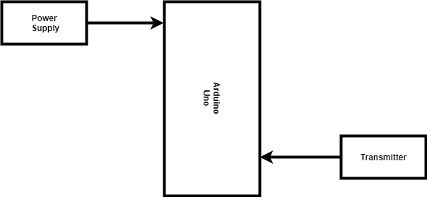

Figure .

### Receiver:

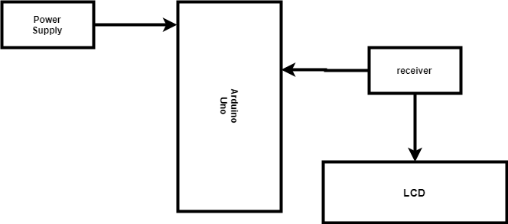

Figure .

### Bluetooth:

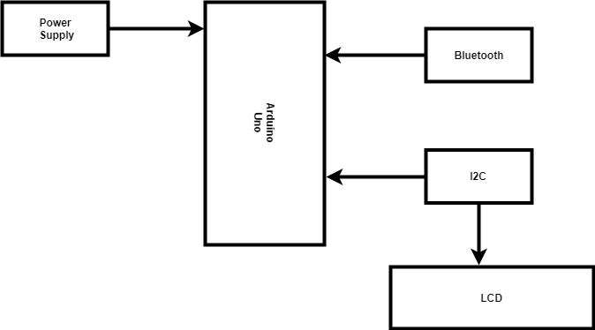

Figure .

### NodeMcu:

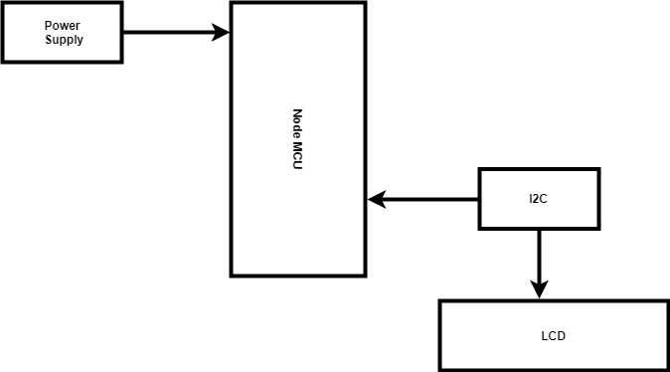

Figure .

## Litreture View:

### For RF module:

Now a day’s providing data security has become very prominent and is increases the quality of communication. If there are no security measures for the data then the data can be easily hacked or diverted which reduces the quality of communication. We see electronic notice boards which store particular information and displays the particular information only till it is provided with new information. In this paper we will look into electronic notice boards which use wireless technology for transferring data by which the new information can be sent. We will see how information is

transferred and different types of notice boards available.

### Bluetooth:

This Project deals with an innovative rather an interesting manner of intimating the message to the people using a wireless electronic display board which is synchronized using the Bluetooth technology. This will help us in passing any message almost immediately without any delay just by sending a SMS which is better and more reliable than the old traditional way of passing the message on notice board. This proposed technology can be used in colleges many public places, malls or big buildings to enhance the security system and also make awareness of the emergency situations and avoid many dangers. Using Bluetooth module display the message onto the display board.

### NodeMcu:

Conventional Notice Board employs manual display and monitoring with papers and ledgers. The Target users are unaware of information displayed on the notice board. The objective of the project is to display the message on the notice board from anywhere and anytime, that even provides broadcast alerts to the target users. The system was designed and developed using the Internet of Things. Arduino board integrates the display unit, Mobile App and SMS Agent through Internet. The message to be displayed on the notice board is sent throu gh a mobile app to the board with Arduino. A system of efficient Notice Board display controlled through the Internet is accomplished and presented in this project.

# Software and hardware Requirement Analysis

## Microcontroller

System contains one microcontroller.

Different microcontrollers were investigated including Pic, CC2530 and Arduino UNO R3.

Arduino UNO R3 was finally chosen because of its low power and low cost consumption.

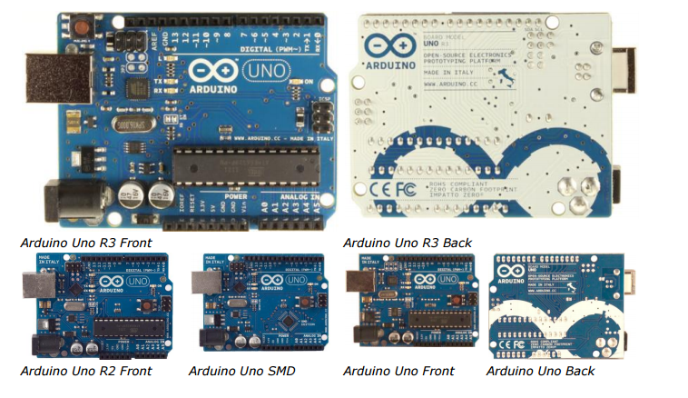

Figure .

Arduino Uno is a microcontroller board based on the ATmega328P ([datasheet](http://www.atmel.com/Images/doc8161.pdf)). It has 14 digital input/output pins (of which 6 can be used as PWM outputs), 6 analog inputs, a 16 MHz quartz crystal, a USB connection, a power jack, an ICSP header and a reset button. It contains everything needed to support the microcontroller; simply connect it to a computer with a USB cable or power it with a AC-to-DC adapter or battery to get started.. You can tinker with your UNO without worring too much about doing something wrong, worst case scenario you can replace the chip for and start over again , chip is not costly and easily available in market .

## Nodemcu esp8266

**NodeMCU** is an open source IoT platform. It includes firmware which runs on the ESP8266 Wi-Fi SoC from Espressif Systems, and hardware which is based on the ESP-12 module. The term "NodeMCU" by default refers to the firmware rather than the development kits. The firmware uses the Lua scripting language. It is based on the eLua project, and built on the Espressif Non-OS SDK for ESP8266. It uses many open source projects, such as lua-cjson and SPIFFS.

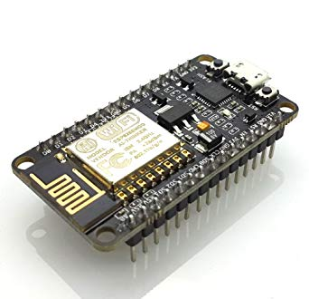

Figure .

## 

## Sketch of NodeMcu

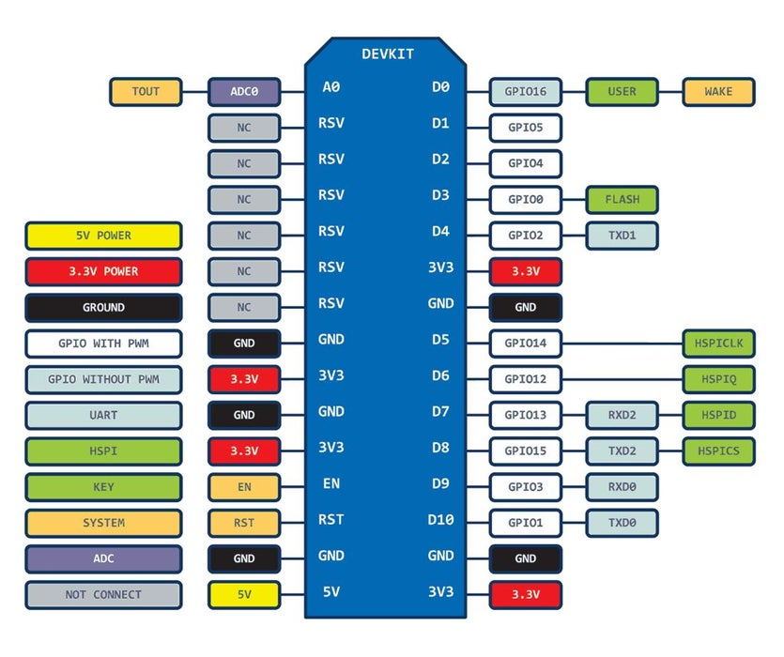

Figure .

The Internet of Things (IoT) has been a trending field in the world of technology. It has changed the way we work. Physical objects and the digital world are connected now more than ever. Keeping this in mind, Espressif Systems (A Shanghai-based Semiconductor Company) has released an adorable, bite-sized WiFi enabled microcontroller – **ESP8266**, at an unbelievable price! For less than $3, it can monitor and control things from anywhere in the world – **perfect for just about any IoT project**.

### ESP-12E Module:

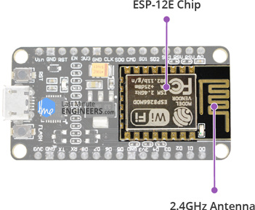The development board equips the ESP-12E module containing ESP8266 chip having **Tensilica Xtensa 32-bit LX106 RISC microprocessor** which operates at **80 to 160 MHz** adjustable clock frequency and supports **RTOS**.

**ESP-12E Chip**

Tensilica Xtensa 32-bit LX106

80 to 160 MHz Clock Freq.

128kB internal RAM

4MB external flash

802.11b/g/n Wi-Fi transceiver

Figure .

There’s also **128 KB RAM and 4MB of Flash memory** (for program and data storage) just enough to cope with the large strings that make up web pages, JSON/XML data, and everything we throw at IoT devices nowadays.

For more details about ESP8266 chip, refer below datasheet.

The ESP8266 Integrates **802.11b/g/n HT40 Wi-Fi transceiver**, so it can not only connect to a WiFi network and interact with the Internet, but it can also set up a network of its own, allowing other devices to connect directly to it. This makes the ESP8266 NodeMCU even more versatile.

For more details about ESP-12E module, refer below datasheet.

### Power Requirement

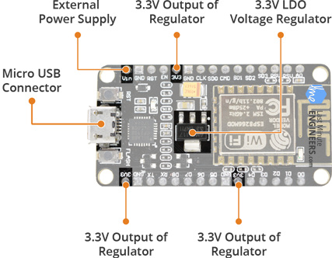As the operating voltage range of ESP8266 is **3V to 3.6V**, the board comes with a LDO voltage regulator to keep the voltage steady at 3.3V. It can reliably supply up to 600mA, which should be more than enough when ESP8266 pulls as much as **80mA during RF transmissions**. The output of the regulator is also broken out to one of the sides of the board and labeled as 3V3. This pin can be used to supply power to external components.

**Power Requirement**

Operating Voltage: 2.5V to 3.6V

On-board 3.3V 600mA regulator

80mA Operating Current

20 µA during Sleep Mode

Figure .

**Power to the ESP8266 NodeMCU**is supplied via the **on-board MicroB USB connector**. Alternatively, if you have a regulated 5V voltage source, the **VIN pin** can be used to directly supply the ESP8266 and its peripherals.

### Peripherals and I/O

The ESP8266 NodeMCU has total **17 GPIO pins** broken out to the pin headers on both sides of the development board. These pins can be assigned to all sorts of peripheral duties, including:

**ADC channel** – A 10-bit ADC channel.

**UART interface** – UART interface is used to load code serially.

**PWM outputs** – PWM pins for dimming LEDs or controlling motors.

**SPI, I2C & I2S interface** – SPI and I2C interface to hook up all sorts of sensors and peripherals.

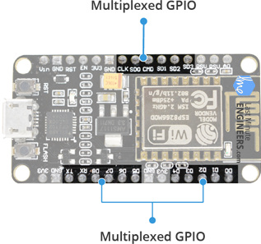**I2S interface** – I2S interface if you want to add sound to your project.

**Multiplexed I/Os**

1 ADC channels

2 UART interfaces

4 PWM outputs

SPI, I2C & I2S interface

Figure .

Thanks to the ESP8266’s **pin multiplexing feature** (Multiple peripherals multiplexed on a single GPIO pin). Meaning a single GPIO pin can act as PWM/UART/SPI.

### On-board Switches & LED Indicator:

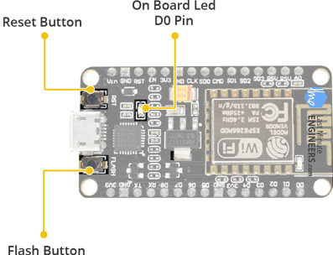The ESP8266 NodeMCU features two buttons. One marked as **RST** located on the top left corner is the Reset button, used of course to reset the ESP8266 chip. The other **FLASH** button on the bottom left corner is the download button used while upgrading firmware.

**Switches & Indicators**

RST – Reset the ESP8266 chip

FLASH – Download new programs

Blue LED – User Programmable

The board also has a**LED indicator** which is user programmable and is connected to the D0 pin of the board.

Figure .

### Serial Communication

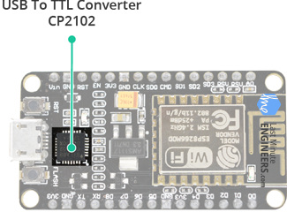The board includes CP2102 USB-to-UART Bridge Controller from Silicon Labs, which converts USB signal to serial and allows your computer to program and communicate with the ESP8266 chip.

Figure .

**Serial Communication**

CP2102 USB-to-UART converter

4.5 Mbps communication speed

Flow Control support

If you have an older version of CP2102 driver installed on your PC, we recommend upgrading now.

### ESP8266 NodeMCU Pinout

The ESP8266 NodeMCU has total 30 pins that interface it to the outside world. The connections are as follows:

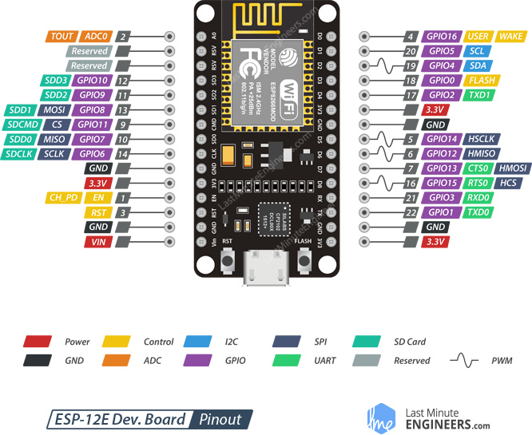

Figure .

For the sake of simplicity, we will make groups of pins with similar functionalities:

**Power pins:** There are four power pins viz. one VIN pin & three 3.3V pins. The VIN pin can be used to directly supply the ESP8266 and its peripherals, if you have a regulated 5V voltage source. The 3.3V pins are the output of an on-board voltage regulator. These pins can be used to supply power to external components.

GND: is a ground pin of ESP8266 NodeMCU development board.

I2C Pins: are used to hook up all sorts of I2C sensors and peripherals in your project. Both I2C Master and I2C Slave are supported. I2C interface functionality can be realized programmatically, and the clock frequency is 100 kHz at a maximum. It should be noted that I2C clock frequency should be higher than the slowest clock frequency of the slave device.

GPIO Pins: ESP8266 NodeMCU has 17 GPIO pins which can be assigned to various functions such as I2C, I2S, UART, PWM, IR Remote Control, LED Light and Button programmatically. Each digital enabled GPIO can be configured to internal pull-up or pull-down, or set to high impedance. When configured as an input, it can also be set to edge-trigger or level-trigger to generate CPU interrupts.

ADC Channel: The NodeMCU is embedded with a 10-bit precision SAR ADC. The two functions can be implemented using ADC viz. Testing power supply voltage of VDD3P3 pin and testing input voltage of TOUT pin. However, they cannot be implemented at the same time.

UART Pins: ESP8266 NodeMCU has 2 UART interfaces, i.e. UART0 and UART1, which provide asynchronous communication (RS232 and RS485), and can communicate at up to 4.5 Mbps. UART0 (TXD0, RXD0, RST0 & CTS0 pins) can be used for communication. It supports fluid control. However, UART1 (TXD1 pin) features only data transmit signal so, it is usually used for printing log.

SPI Pins: ESP8266 features two SPIs (SPI and HSPI) in slave and master modes. These SPIs also support the following general-purpose SPI features:

4 timing modes of the SPI format transfer

Up to 80 MHz and the divided clocks of 80 MHz

Up to 64-Byte FIFO

SDIO Pins: ESP8266 features Secure Digital Input/Output Interface (SDIO) which is used to directly interface SD cards. 4-bit 25 MHz SDIO v1.1 and 4-bit 50 MHz SDIO v2.0 are supported.

PWM Pins:The board has 4 channels of Pulse Width Modulation (PWM). The PWM output can be implemented programmatically and used for driving digital motors and LEDs. PWM frequency range is adjustable from 1000 μs to 10000 μs, i.e., between 100 Hz and 1 kHz.

Control Pins: are used to control ESP8266. These pins include Chip Enable pin (EN), Reset pin (RST) and WAKE pin.

EN pin – The ESP8266 chip is enabled when EN pin is pulled HIGH. When pulled LOW the chip works at minimum power.

RST pin – RST pin is used to reset the ESP8266 chip.

WAKE pin – Wake pin is used to wake the chip from deep-sleep.

## I2C Module:

An **inter**-**integrated circuit** (**Inter**-**IC** or I2C) is a multi-master serial bus that connects low-speed peripherals to a motherboard, mobile phone, embedded system or other electronic devices. Also known as a two-wire interface.

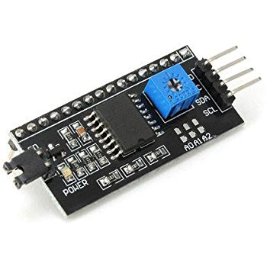

Figure .

This is an 16x2 LCD display screen with I2C interface. It is able to display 16x2 characters on 2 lines, white characters on blue background.

Usually, Arduino LCD display projects will run out of pin resources easily, especially with Arduino Uno. And it is also very complicated with the wire soldering and connection.

This I2C 16x2 Arduino LCD Screen is using an I2C communication interface. It means it only

needs 4 pins for the [LCD](https://www.dfrobot.com/category-130.html) display: VCC, GND, SDA, SCL. It will saves at least 4 digital / analog

pins on [Arduino](https://www.dfrobot.com/category-35.html). All connector are standard XH2.54 (Breadboard type). You can connect with [jumper wire](https://www.dfrobot.com/product-356.html) directly.­­­­

### SPECIFICATION

Compatible with Arduino/Genuino UNO, Leonardo, Mega, 101 (Intel Curie), Micro, Nano, Mini

I2C Address:0x20-0x27(0x20 default)

Back lit (Blue with white char color)

Supply voltage: 5V

Interface:I2C/TWI x1,Gadgeteer interface x2

Adjustable contrast

Size:82x35x18 mm (3.2x1.4x0.7 in)

## Bluetooth Module(hc-05):

HC‐05 module is an easy to use Bluetooth SPP (Serial Port Protocol) module,designed for transparent wireless serial connection setup.The HC-05 ­­­­­­Bluetooth Module can be used in a Master or Slave configuration, making it a great solution for wireless communication.This serial port bluetooth module is fully qualified Bluetooth V2.0+EDR (Enhanced Data Rate)3Mbps Modulation with complete 2.4GHz radio transceiver and baseband. It uses CSR Bluecore **04**‐External single chip Rluetooth system with CMOS technology and with AFH (Adaptive Frequency Hopping Feature)

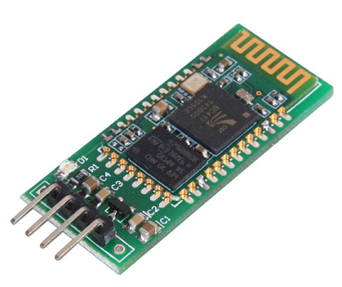

Figure .

.

### Types of Bluetooth Module

1. HC-05
2. HC-06 RS232 TTL
3. BLE Link Bee
4. BLE Mini
5. BlueSMiRF
6. JY-MCU

### ****Pin Configuration****

|  |  |  |
| --- | --- | --- |
| **Pin Number** | **Pin Name** | **Description** |
| 1 | Enable / Key | This pin is used to toggle between Data Mode (set low) and AT command mode (set high). By default it is in Data mode |
| 2 | Vcc | Powers the module. Connect to +5V Supply voltage |
| 3 | Ground | Ground pin of module, connect to system ground. |
| 4 | TX – Transmitter | Transmits Serial Data. Everything received via Bluetooth will be given out by this pin as serial data. |
| 5 | RX – Receiver | Receive Serial Data. Every serial data given to this pin will be broadcasted via Bluetooth |
| 6 | State | The state pin is connected to on board LED, it can be used as a feedback to check if Bluetooth is working properly. |
| 7 | LED | Indicates the status of Module  Blink once in 2 sec: Module has entered Command Mode  Repeated Blinking: Waiting for connection in Data Mode  Blink twice in 1 sec: Connection successful in Data Mode |
| 8 | Button | Used to control the Key/Enable pin to toggle between Data and command Mode |

### How to connect HC05 bluetooth module with Arduino Uno?

As we know that Vcc and Gnd of the module goes to Vcc and Gnd of Arduino.The TXD pin goes to RXD pin of Arduino and RXD pin goes to TXD pin of Arduino i.e(digital pin 0 and 1).

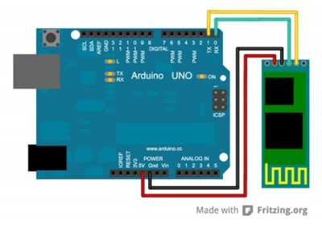

Figure .

## RF Module:

An RF module (radio frequency module) is a (usually) small electronic device used to transmit and/or receive radio signals between two devices. In an embedded system it is often desirable to communicate with another device wirelessly. This wireless communication may be accomplished through optical communication or through radio frequency (RF) communication. For many applications the medium of choice is RF since it does not require line of sight. RF communications incorporate a transmitter and a receiver . They are of various types and ranges. Some can transmit up to 500 feet. RF modules are widely used in electronic design owing to the difficulty of designing radio circuitry.

### Use of rf

RF modules are most often used in medium and low volume products for consumer applications such as garage door openers, wireless alarm or monitoring systems, industrial remote controls, smart sensor applications, and wireless home automation systems. They are sometimes used to replace older infrared communication designs as they have the advantage of not requiring line-of-sight operation.

### Frequency

Several carrier frequencies are commonly used in commercially available RF modules, including those in the industrial, scientific and medical (ISM) radio bands such as 433.92 MHz, 915 MHz, and 2400 MHz. These frequencies are used because of national and international regulations governing the used of radio for communication. Short Range Devices may also use frequencies available for unlicensed such as 315 MHz and 868 MHz..

### Types of RF Module:

The term RF module can be applied to many different types, shapes and sizes of small electronic.

Transmitter module

Receiver module

### Transmitter module:

An RF transmitter module is a small PCB sub-assembly capable of transmitting a radio wave and modulating that wave to carry data. Transmitter modules are usually implemented alongside a micro controller which will provide data to the module which can be transmitted. RF transmitters are usually subject to regulatory requirements which dictate the maximum allowable transmitter power output, harmonics, and band edge requirements.

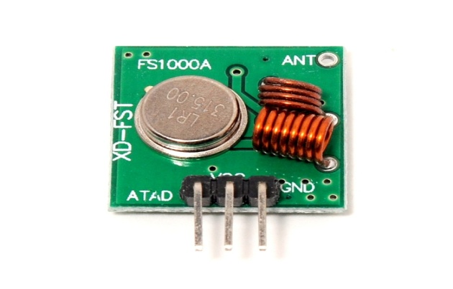

Figure .

### Reciver Module:

An RF receiver module receives the modulated RF signal, and demodulates it. There are two types of RF receiver modules: superheterodyne receivers and super-regenerative receivers. Super-regenerative modules are usually low cost and low power designs using a series of amplifiers to extract modulated data from a carrier wave. Super-regenerative modules are generally imprecise

as their frequency of operation varies considerably with temperature and power supply

voltage. Superheterodyne receivers have a performance advantage over super-regenerative; they offer increased accuracy and stability over a large voltage and temperature range. This stability comes from a fixed crystal design which in the past tended to mean a comparatively more expensive product. However, advances in receiver chip design now mean that currently there is little price difference between super heterodyne and super-regenerative receiver modules.

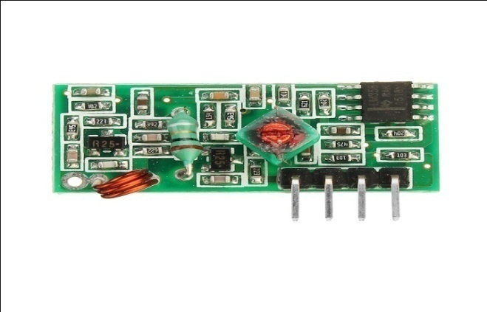

Figure .

## LCD 1602

LCD1602, or 1602 character-type liquid crystal display, is a kind of dot matrix module to show letters, numbers, and characters and so on. It's composed of 5x7 or 5x11 dot matrix positions; each position can display one character. There's a dot pitch between twocharacters and a space between lines, thus separating characters and lines. The model 1602 means it displays 2 lines of 16 characters.  
Generally, LCD1602 has parallel ports, that is, it would control several pins at the same time. LCD1602 can be categorized into eight-port and four-port connections. If the eight-port connection is used, then all the digital ports of the SunFounder Uno board are almost completely occupied. If you want to connect more sensors, there will be no ports available. Therefore, the four-port connection is used here for better application.  These modules are preferred over seven segments and other multi segment LEDs. The reasons being: LCDs are economical; easily programmable; have no limitation of displaying special & even custom characters (unlike in seven segments), animations and so on. he command register stores the command instructions given to the LCD. A command is an instruction given to LCD to do a predefined task like initializing it, clearing its screen, setting the cursor position, controlling display etc.

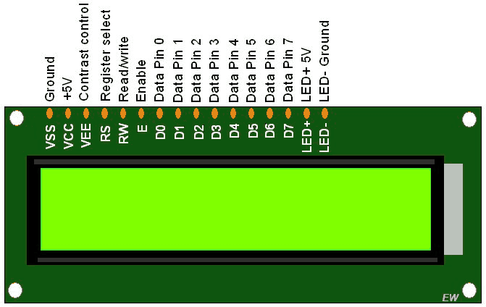

Figure .

### Pin Description:

|  |  |  |
| --- | --- | --- |
| Pin No | Function | Name |
| 1 | Ground (0V) | Ground |
| 2 | Supply voltage; 5V (4.7V – 5.3V) | Vcc |
| 3 | Contrast adjustment; through a variable resistor | VEE |
| 4 | Selects command register when low; and data register when high | Register Select |
| 5 | Low to write to the register; High to read from the register | Read/write |
| 6 | Sends data to data pins when a high to low pulse is given | Enable |
| 7 | 8-bit data pins | DB0 |
| 8 | DB1 |
| 9 | DB2 |
| 10 | DB3 |
| 11 | DB4 |
| 12 | DB5 |
| 13 | DB6 |
| 14 | DB7 |
| 15 | Backlight VCC (5V) | Led+ |
| 16 | Backlight Ground (0V) | Led- |

## Potentiometer:

A potentiometer is a three-terminal resistor with a sliding or rotating contact that forms an adjustable voltage divider. If only two terminals are used, one end and the wiper, it acts as

a variable resistor or rheostat.

The measuring instrument called a potentiometer is essentially a voltage divider used for measuring electric potential (voltage); the component is an implementation of the same principle, hence its name.

Potentiometers are commonly used to control electrical devices such as volume controls on audio equipment. Potentiometers operated by a mechanism can be used as position transducers, for example, in a joystick.

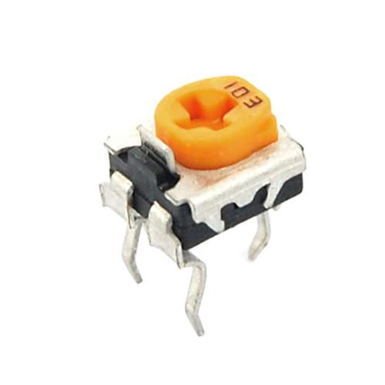

Figure .

### Potentiometer Symbols

In a circuit diagram, a potentiometer is represented by one of the two symbols below:

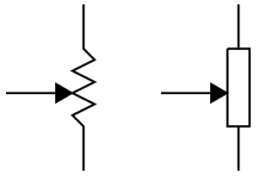

Figure .

### How Does a Potentiometer Work?

A potentiometer has 3 pins. Two terminals (the blue and green) are connected to a resistive element and the third terminal (the black one) is connected to an adjustable wiper.

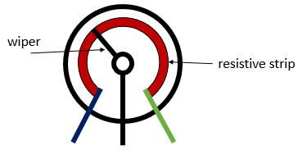

Figure .

The potentiometer can work as a **rheostat**(variable resistor) or as a **voltage divider.**

### Rheostat

To use the potentiometer as a rheostat, only two pins are used: one outside pin and the center pin. The position of the wiper determines how much resistance the potentiometer is imposing to the circuit, as the figure demonstrates.

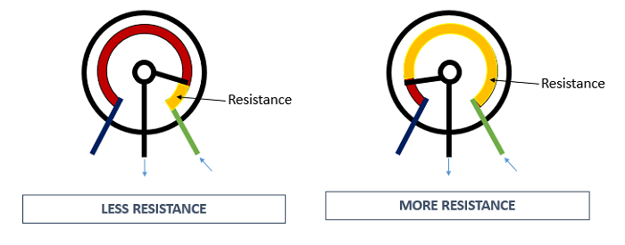

Figure .

If we have a 10kΩ potentiometer, it means that the maximum resistance of the variable resistor is 10kΩ and the minimum is 0Ω. This means that by changing the wiper position, you get a value between 0Ω and 10kΩ.

### Voltage Divider

Potentiometers can be used as voltage dividers. To use the potentiometer as a voltage divider, all the three pins are connected. One of the outer pins is connected to the GND, the other to Vcc and the middle pin is the voltage output.

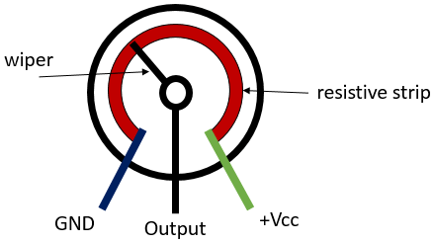

Figure .

When the potentiometer is used as a voltage divider, the wiper position determines the output voltage. When you have the potentiometer connected this way, you have the following circuit:

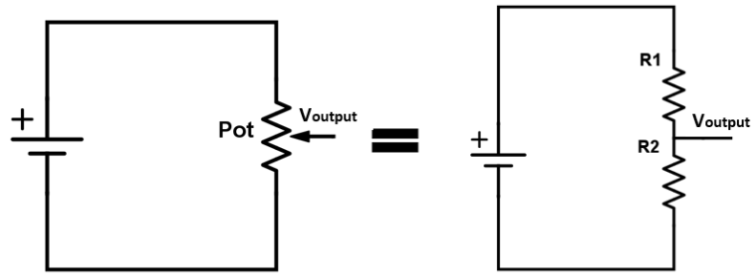

Figure .

Basically, the voltage divider is used to turn a large voltage into a smaller one.

The output voltage can be calculated using the following equation obtained from Ohm’s Law:

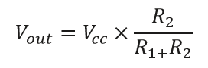

Figure .

Potentiometer Taper:

One main concept associated with potentiometers is the taper. The taper is the relationship between the position and the resistance of the potentiometer. The most common types are linear and logarithmic tapers.

### Linear potentiometers:

The most common form is the simple linear taper. In a linear taper, the relationship between the resistance and the potentiometer position is linear.\This means that if the knob of the potentiometer is at the medium position, the output voltage is half of the voltage through the potentiometer. See the figure below:

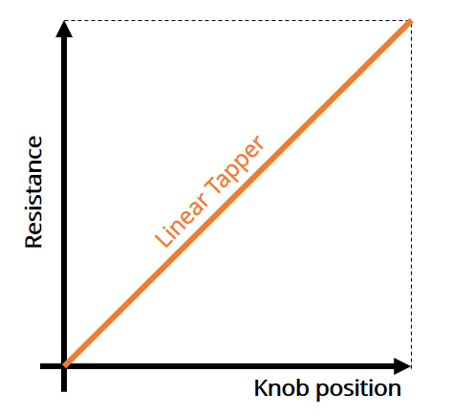

Figure .

Potentiometers with linear taper are marked with a B.

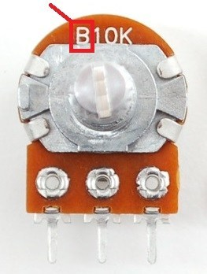

Figure .

### Logarithmic potentiometers

Non-linear tapers are specially used in audio control applications, namely logarithmictapers (there are also inverse-logarithmic tapers). The relationship between the position and the resistance is shown in the following figure:

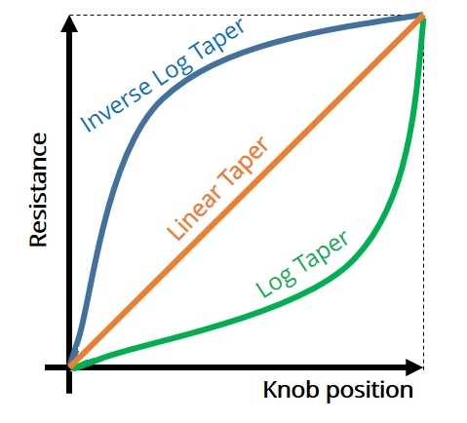

Figure .

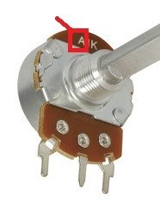Potentiometers with logarithmic taper are marked with an A.

Figure .

## Resistor:

A resistor is a passive two-terminal electrical component that implements electrical resistance as a circuit element. In electronic circuits, resistors are used to reduce current flow, adjust signal levels, to divide voltages, bias active elements, and terminate transmission lines, among other uses. High-power resistors that can dissipate many watts of electrical power as heat, may be used as part of motor controls, in power distribution systems, or as test loads for generators. Fixed resistors have resistances that only change slightly with temperature, time or operating voltage. Variable resistors can be used to adjust circuit elements (such as a volume control or a lamp dimmer), or as sensing devices for heat, light. Resistors are electronic components which have a specific, never-changing [electrical resistance](https://learn.sparkfun.com/tutorials/voltage-current-resistance-and-ohms-law/resistance). The resistor's resistance limits the flow of electrons through a circuit.

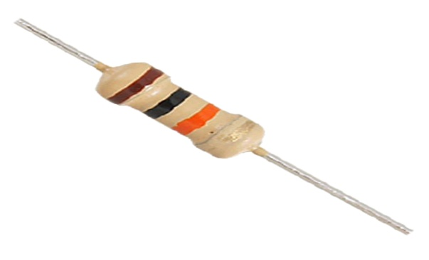

Figure .

Resistors are common elements of electrical networks and electronic circuits and are ubiquitous in electronic equipment. Practical resistors as discrete components can be composed of various compounds and forms. Resistors are also implemented within integrated circuits.

### How does a resistor work?

Let’s start with some vocabulary:

Electricity is the flow of electrons, which are negatively charged particles.

Voltage is the difference in charge between two points in a circuit. Voltage is also theforce of an electrical current.

Current measures how fast the electrons are flowing.

A simple way to understand the difference between voltage and current is to think of a tank of water draining through a hose attached to a hole in the bottom. Here, the water is acting like the flow of electricity. The voltage is the amount of water pressure, and the current is how fast the water flows.

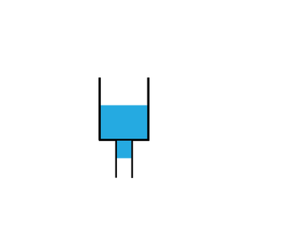

Figure .

Resistance measures a materials ability to resist the flow of electrons through it.

If the width of the hose at the bottom remains the same, then by adding more water to the tank, the water through the hose flow faster. similarly adding move voltage to a circuit increases the current.

However, if the hose is replaced by a smaller hose, the same amount of water pressure produces a slower flow of water. The size of the hose provides resistance, and reduces the current. A resistor in a circuit plays the same role, reducing the current through the components they are used with

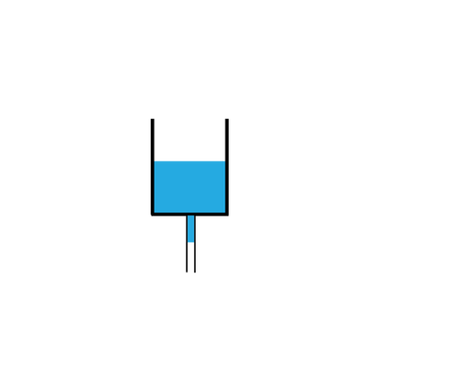

Figure .

### How do resistors resist?

The resistors in MakeCrate projects are through-hole resistors, designed with two flexible ends for bending and inserting in a breadboard. The core of the resistor is made of a helix, or spiral, of conductive material wrapped around an insulating core. The material is very, very thin, which forces the current to slow down to pass through, providing resistance. To increase the amount of resistance, the number of loops in the spiral can be increased.

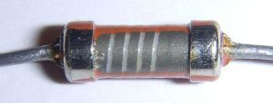

Figure .

### What happens if I don’t use a resistor?

If the current through a component is too much for the component to handle, it can overheat the component and possible damage it, or it could cause damage to your microcontroller (Arduino). LEDs will burn out quickly if not used with proper resistance.

If you want to safely see a the effect a resistor can have on a circuit, build a circuit like in your “Make Some Noise” project, but instead of connecting the buzzer to ground with a wire, use a resistor. You’ll see that the reduced current causes the buzzer to be much quieter.

## Breadboard:

A breadboard is a solderless device for temporary prototype with electronics and test circuit designs. Most electronic components in electronic circuits can be interconnected by inserting their leads or terminals into the holes and then making connections through wires where appropriate. The breadboard has strips of metal underneath the board and connect the holes on the top of the board. The metal strips are laid out as shown below. Note that the top and bottom rows of holes are connected horizontally and split in the middle while the remaining holes are connected vertically.

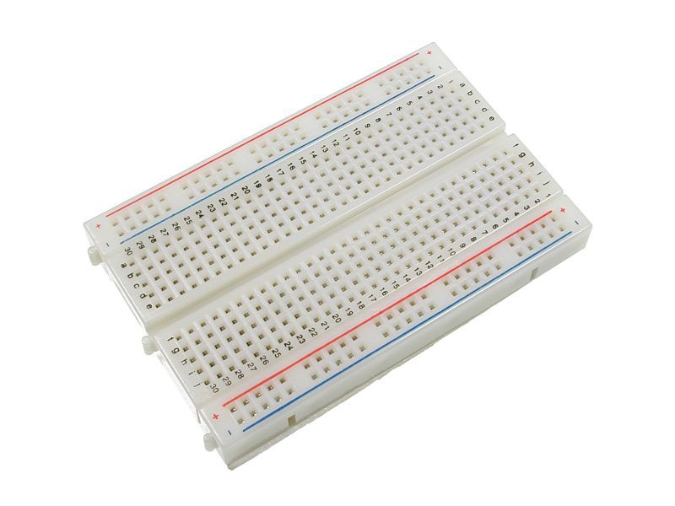

Figure .

### What is inside a breadboard ?

The leads can fit into the breadboard because the *inside* of a breadboard is made up of rows of tiny metal clips. This is what the clips look like when they are removed from a breadboard.

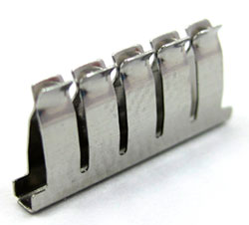

Figure .

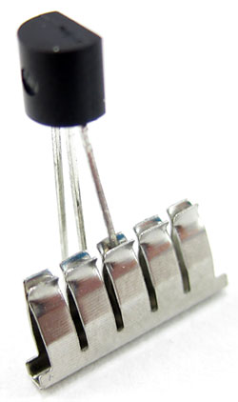When you press a component's lead into a breadboard hole, one of these clips grabs onto it.

Figure .

Some breadboards are actually made of transparent plastic, so you can see the clips inside.

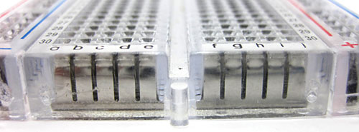

Figure .

Most breadboards have a backing layer that prevents the metal clips from falling out. The backing is typically a layer of sticky, double-sided tape covered by a protective layer of paper. If you want to permanently "stick" the breadboard to something (for example, a robot), you just need to peel off the paper layer to expose the sticky tape underneath. In this picture, the breadboard on the right has had its backing removed completely (so you can see all the metal clips). The breadboard on the left still has its sticky backing, with one corner of the paper layer peeled up.

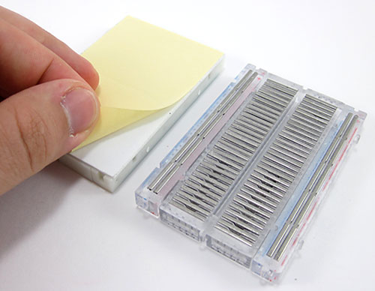

Figure .

### What do the letters and numbers on a breadboard mean?

Most breadboards have some numbers, letters, and plus and minus signs written on them. What does all that mean? While their exact appearance might vary from breadboard to breadboard, the general purpose is always the same. These labels help you locate certain holes on the breadboard so you can follow directions when building a circuit. If you have ever used a spreadsheet program like Microsoft Excel® or Google Sheets™, the concept is exactly the same. Row numbers and column letters help you identify individual holes in the breadboard, just like cells in a spreadsheet. For example, all of the highlighted holes are in "column C."

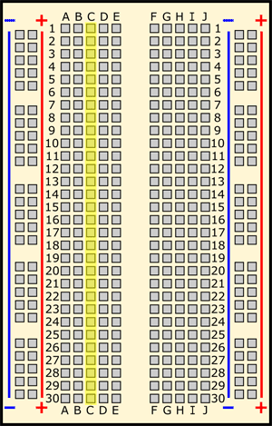

Figure .

All of the highlighted holes are in "row 12."

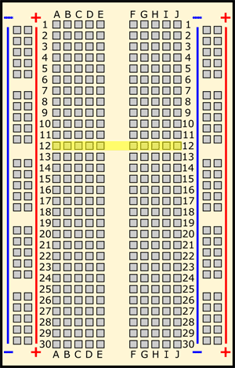

Figure .

“Hole C12" is where column C intersects row 12.

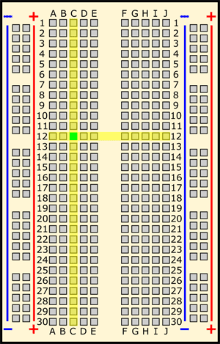

Figure .

### What do the colored lines and plus and minus signs mean?

What about the long strips on the side of the breadboard, highlighted in yellow here?

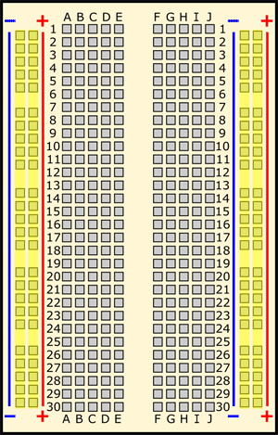

Figure .

These strips are typically marked by red and blue (or red and black) lines, with plus (+) and minus (-) signs, respectively. They are called the buses, also referred to as rails, and are typically used to supply electrical power to your circuit when you connect them to a battery pack or other external power supply. You may hear the buses referred to by different names; for example, *power bus*, *positive bus*, and *voltage bus* all refer to the one next to the red line with the plus (+) sign. Similarly, negative busand ground bus both refer to one next to the blue (or black) line with the minus (-) sign. Sound confusing? Use this table to help you remember—there are different ways to refer to the buses, but they all mean the same thing. Do not worry if you see them referred to by different names in different places (for example, in different Science Buddies projects or other places on the internet). Sometimes you might hear "power buses" (or rails) used to refer to *both* of the buses (or rails) together, not just the positive one.

| Positive | Negative |
| --- | --- |
| Power | Ground |
| Plus sign (+) | Minus sign (-) |
| Red | Blue or black |

Note that there is no physical difference between the positive and negative buses, and using them is not a requirement. The labels just make it easier to organize your circuit, similar to color-coding your wires.

### How are the holes connected?

Remember that the inside of the breadboard is made up of sets of five metal clips. This means that each set of five holes forming a half-row (columns A–E or columns F–J) is electrically connected. For example, that means hole A1 is electrically connected to holes B1, C1, D1, and E1. It is *not* connected to hole A2, because that hole is in a different row, with a separate set of metal clips. It is also *not* connected to holes F1, G1, H1, I1, or J1, because they are on the other "half" of the breadboard—the clips are not connected across the gap in the middle (to learn about the gap in the middle of the breadboard, see the Advanced section). Unlike all the main breadboard rows, which are connected in sets of five holes, the buses typically run the entire length of the breadboard (but there are some exceptions). This image shows which holes are electrically connected in a typical half-sized breadboard, highlighted in yellow lines.

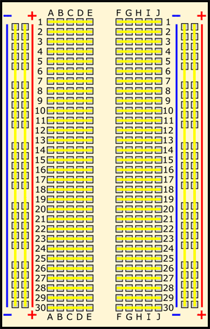

Figure .

Buses on opposite sides of the breadboard are *not* connected to each other. Typically, to make power and ground available on both sides of the breadboard, you would connect the buses with

jumper wires, like this. Make sure to connect positive to positive and negative to negative (see the section on buses if you need a reminder about which color is which).

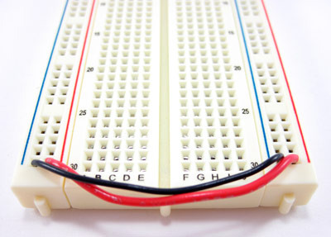

Figure .

## 9v Battery:

The nine-volt battery, or 9-volt battery, is a common size of battery that was introduced for the early transistor radios. It has a rectangular prism shape with rounded edges and a polarized snap connector at the top. This type is commonly used in walkie-talkies, clocks and smoke detectors.

Works with a variety of devices including digital cameras, game controllers, toys, and clocks; do not attempt to recharge.

1. Power Plus 9 Volt batteries power everyday devices
2. Power for your nonstop family’s must-have devices like toys, flashlights, remotes, and more
3. Nominal voltage: 9 V
4. Impedance: 1,700 m-ohm @ 1 kHz
5. Typical weight: 45 g (1.6 oz)
6. Typical volume: 22.8 cm (1.4 in).

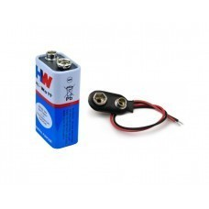

Figure .

## Jumper Wires:

Jumper wires are simply wires that have connector pins at each end, allowing them to be used to connect two points to each other without soldering. Jumper wires are typically used with breadboards and other prototyping tools in order to make it easy to change a circuit as

needed. Fairly simple. In fact, it doesn’t get much more basic than jumper wires.

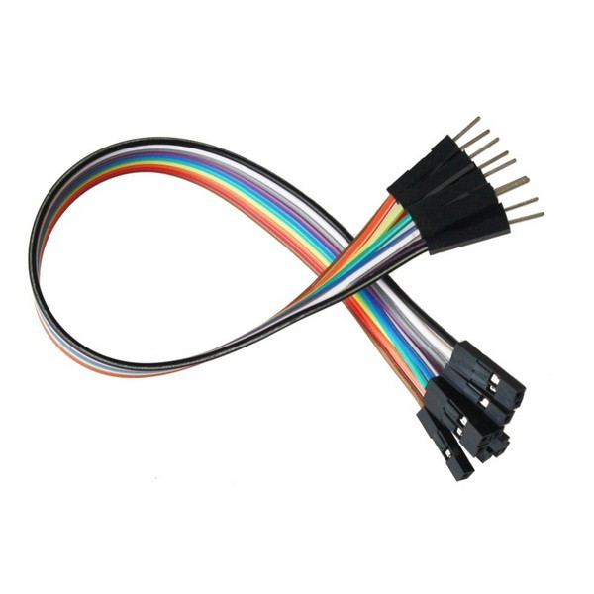

figure.

### Types of wires:

Jumper wires typically come in three versions: male-to-male, male-to-female and female-to-female. The difference between each is in the end point of the wire. Male ends have a pin

protruding and can plug into things, while female ends do not and are used to plug things into. Male-to-male jumper wires are the most common and what you likely will use most often. When

connecting two ports on a breadboard, a male-to-male wire is what you’ll need.

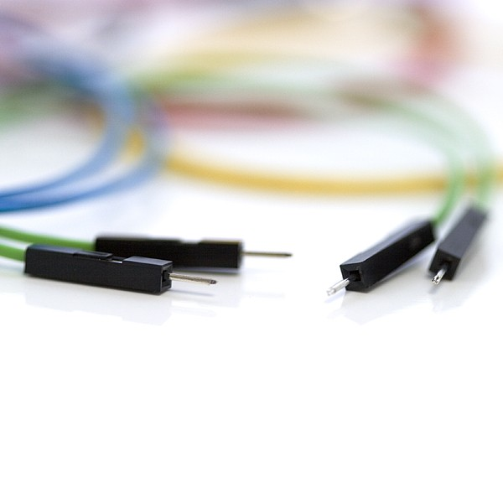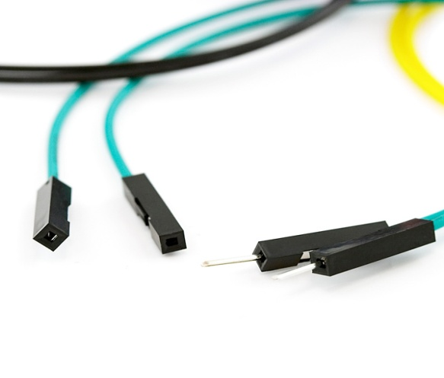

Figure .

## Transparent Box

Transparent Box is used for keeping my all the component It is not a component of my project , I used it for only to summarize my project at one box **.**

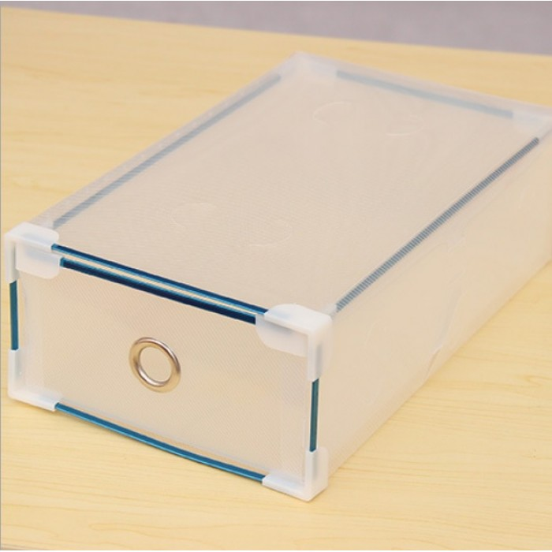

figure.

# System Design

## Design strategy :

### RF Module:

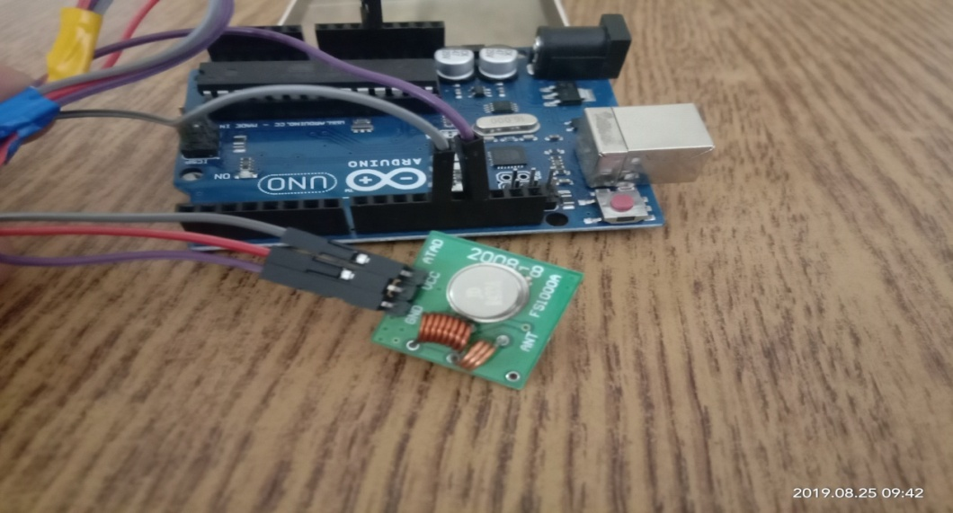

Figure .

Making RF module Arduino & Transmitter is required.

Transmitter Mdule is connected with Arduino.

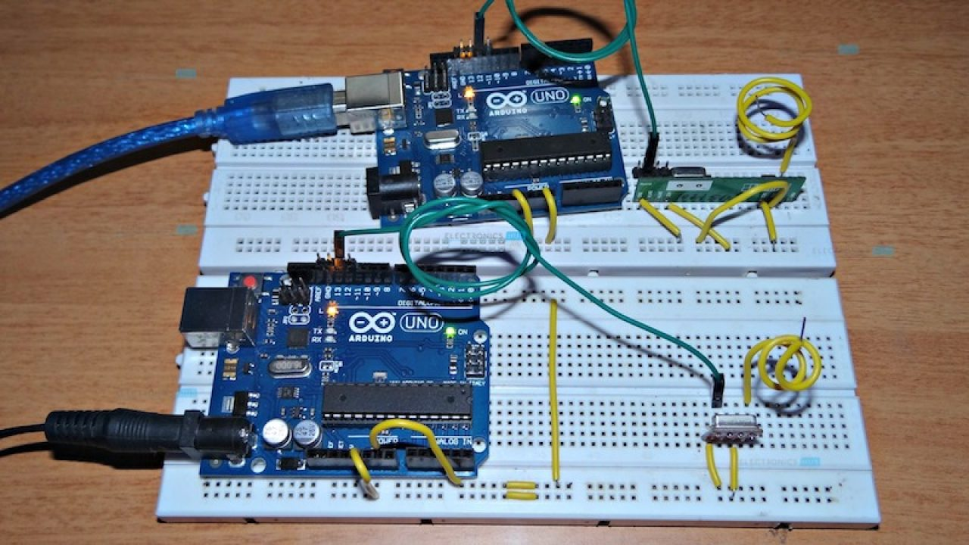

Figure .

Two different Arduino are used in Wirless Notice Board using RF module.

1st Arduino is connected with transmitter .2nd is connect with recive of RF Module.

Then give the power to arduino from Laptop/Computer.

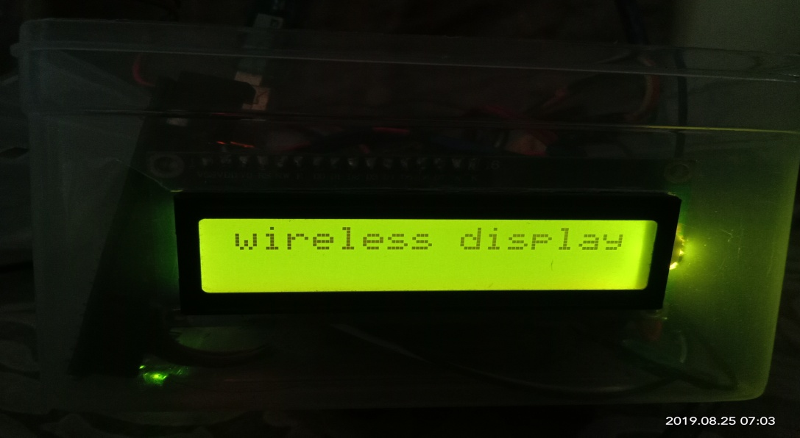

Figure .

After sending the msg through Transmitter Module , Message Display on the LCD.

### Bluetooth :

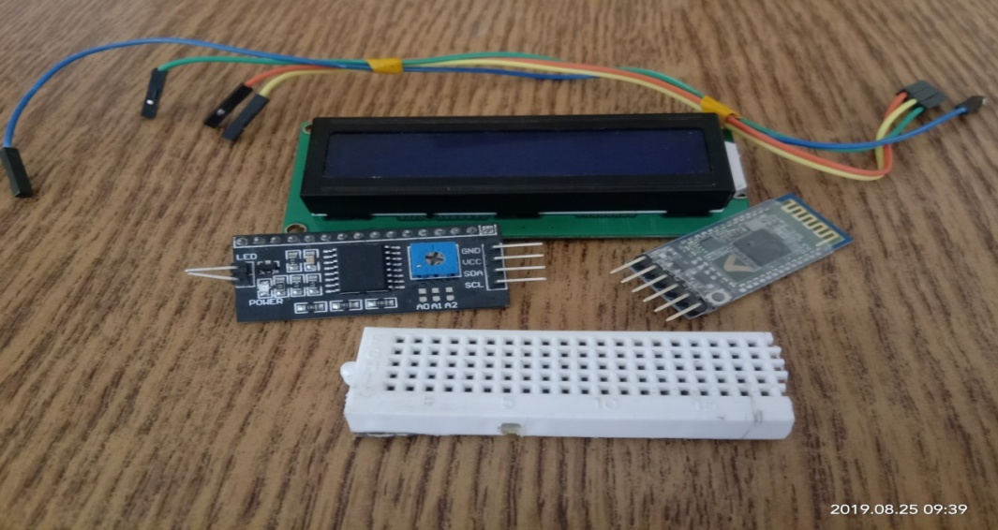

Figure .

This part is used in Wirless Notice Board using Bluetooth.

1. Bluetooth.
2. Arduino.
3. I2C.
4. LCD.
5. Breadboard.
6. .wires.

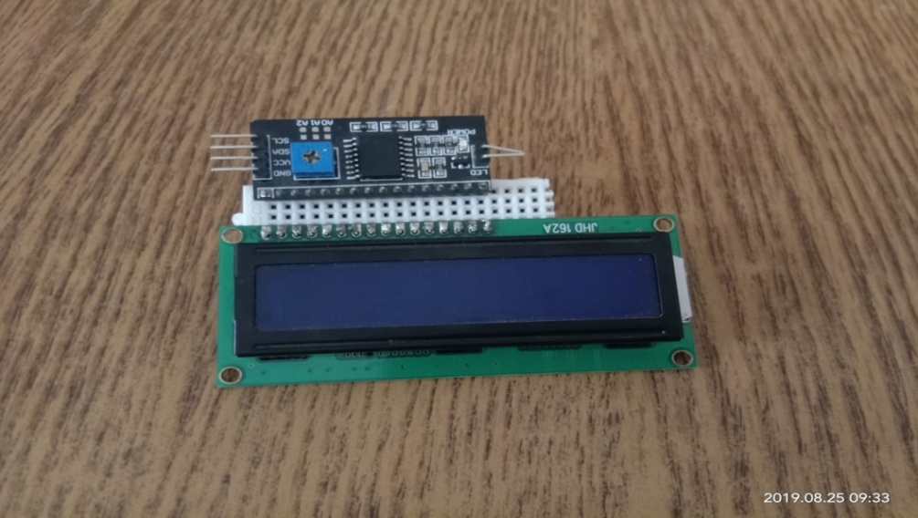

Figure .

I2C Module is connected with LCD.

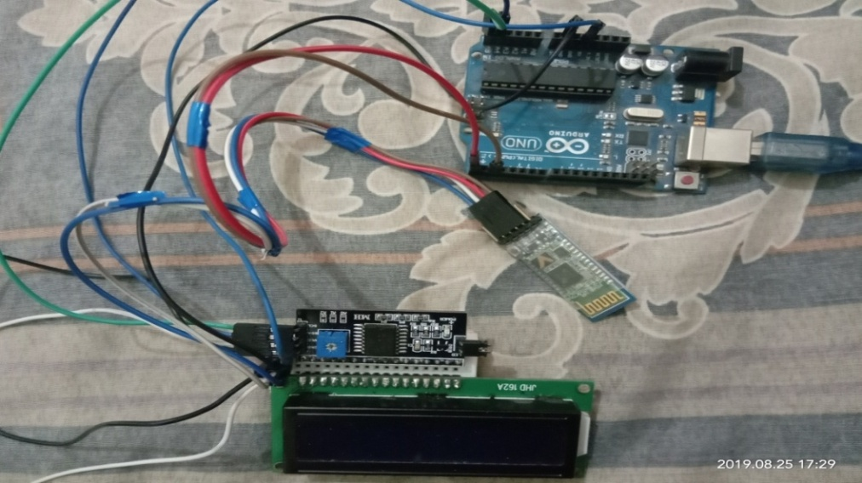

Figure .

LCD is connected with Bluetooth and Arduino.

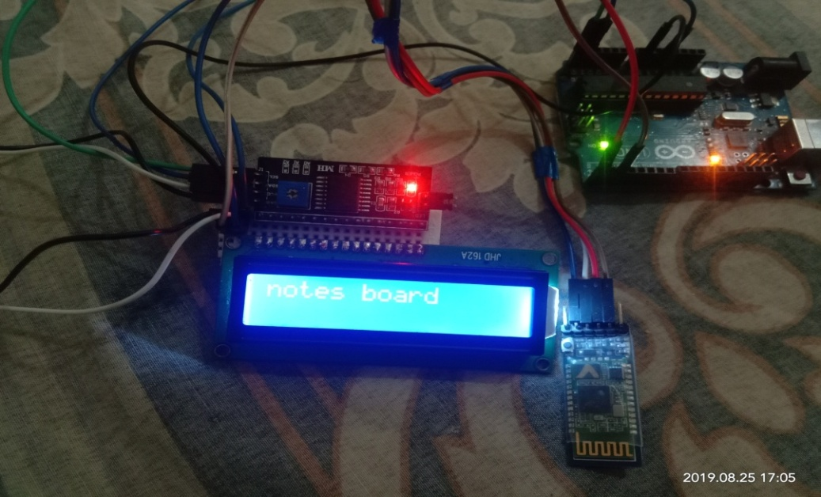

Figure .

After sending the message , message display on the LCD.

### NodeMcu:

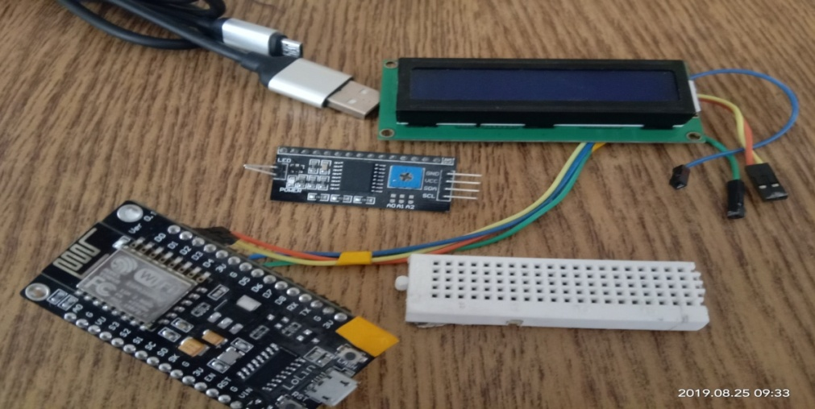

Figure .

This part is used in wirless notice board using NodeMcu.

1. NodeMcu
2. Arduino.
3. I2C.
4. LCD.
5. Breadboard.
6. .wires.

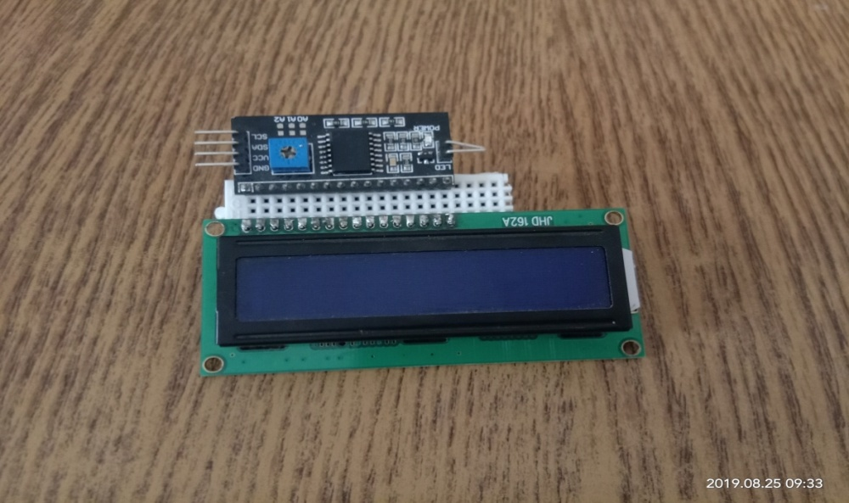

0.9

Figure .

I2C Module is connected with LCD.

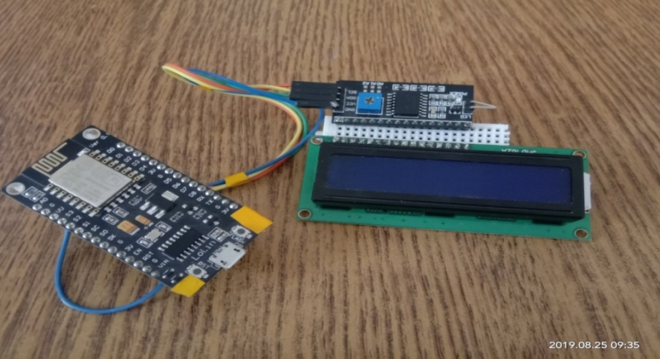

figure.

I2C Module is connected with LCD Then I2C is connected with NodeMcu Module.

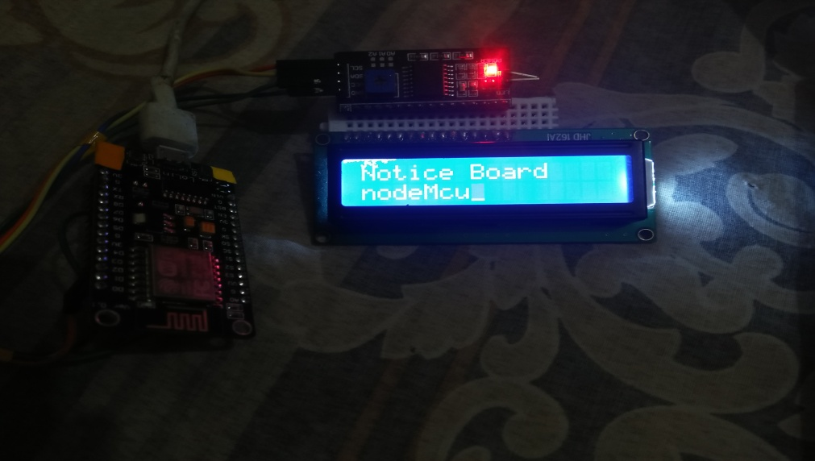

Figure .

Message is send through MQTT server .NodeMcu Receive the message and Display on the screen.

## Communication method :

### For RF Module:

Radio frequency (RF) refers to the rate of oscillation of electromagnetic radio waves in the range of 3 kHz to 300 GHz, as well as the alternating currents carrying the radio signals. This is the

frequency band that is used for communications transmission and broadcasting. Although RF really stands for the rate of oscillation of the waves, it is synonymous to the term "radio," or simple wireless communication.

### For Bluetooth

Bluetooth is a short-range wireless communication technology that allows devices such as mobile phones, computers, and peripherals to transmit data or voice wirelessly over a short distance. The purpose of Bluetooth is to replace the cables that normally connect devices, while still keeping the communications between them secure.

### For NodeMCU

I was doing some experiments with Arduino connected to WiFi using ESP8266 module. The priority of my experiment was to establish MQTT communication with my local MQTT server and Arduino. I tried so many Arduino libraries for ESP8266 but none of them are compatible with PubSubClient, a good MQTT library for Arduino. Today I come across a library called WiFiEsp, it has similar footprints of Arduino WiFi library, and it can work with PubSubClient. This post deals with how to utilize both PubSubClient and WifiEsp libraries to establish MQTT communication with an MQTT server

.

### Robustness

RF refers to the frequencies that fall with in the electromagnetic spectrum associated with radio wave propagation. RF current creates electromagnetic fields when applied to an antenna that propagate the applied signal through space. Electromagnetic wave based communications have been utilized for many decades especially for wireless voice communications and data communications. The frequency of RF signal is inversely proportional to the wavelength of the field. The rate of oscillation for the radio frequencies is in the range about 30 KHz to 300 GHz.

Bluetooth is a short-range wireless communication technology that allows devices such as mobile phones, computers, and peripherals to transmit data or voice wirelessly over a shor distance. The purpose of Bluetooth is to relace the cable that nornaly connected device

# Implementation

## Implementation of RF Module:

In this era of Bluetooth, WiFi and IoT we are somewhere forgetting the old Radio frequency modulations used to transmit data wireless. Here I'm presenting a very simple wireless data link between a computer/laptop and an Arduino uno which can display the data sent from the computer terminal wirelessly on a 16x2 LCD.

This project can be used as a wireless message display board, the display can easily be changed to a dot matrix display or a larger LCD like 20x4. You can send text data over the wireless link which uses the ISM band frequency of 433MHz which is free and unlicensed.

This project can also used with multiple displays. A single transmitter sending data on a frequency of 433MHz and multiple receviers with LCDs can be used to display the same message on all the LCDs.

It can be used to digital advertising purpose or for displaying other notices/messages.

### Step 1: Wireless Notice Board System Using Arduino

Here in this I'm presenting a simple Wireless notice board system made using two Arduinos and 434 MHz ASK RF Modules.

This system can be used in schools and colleges to flash a notice or message on a LCD. Multiple receivers can be used to receive the same message across the whole college campus.  
The message to be displayed is given to the transmitting arduino from PC/Laptop via the serial monitor in Arduino IDE.

Let's get started!!

## Step 2: Parts Require

1.Two Arduino boards(I'm using an Arduino Uno )

2.434 MHz ASK RF module pair

3.16 x 2 LCD

4.Connecting wires

5.10 k potentiometer

### Step 3: Connection Diagram

### Transmitter:

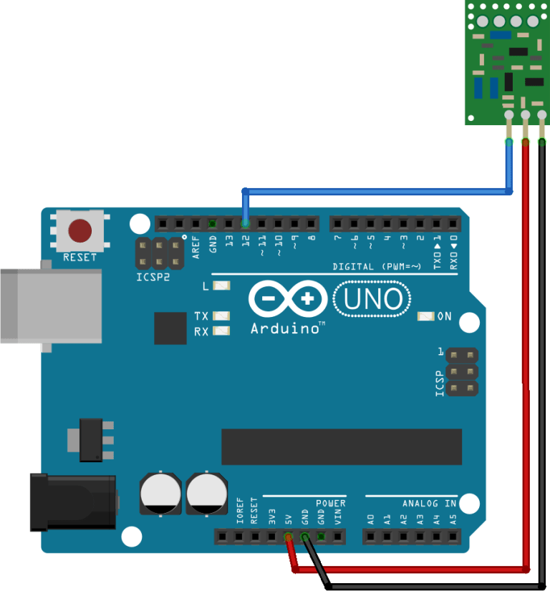

Figure .

The transmitter GND pins connected to arduino GND.

VCC pin connected with arduino VCC.

The DATA pin of transmitter is connect to arduino D12.

**Recevier**

.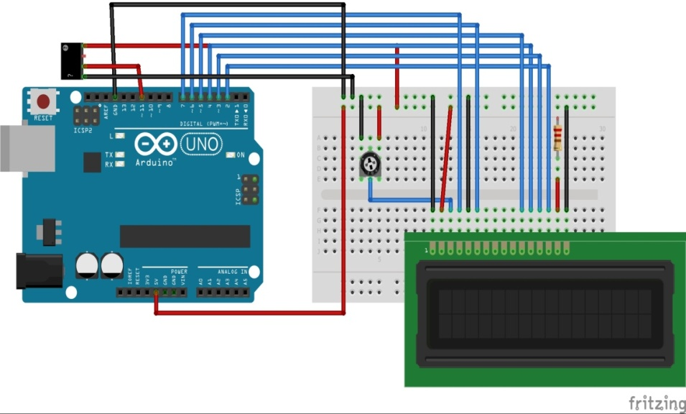

Figure .

Here's a brief about connection diagram.

To wire your LCD screen to your board, connect the following pins:

LCD RS pin to digital pin 7

LCD Enable pin to digital pin 6

LCD D4 pin to digital pin 5

LCD D5 pin to digital pin 4

LCD D6 pin to digital pin 3

LCD D7 pin to digital pin 2

Additionally, wire a 10k pot to +5V and GND, with it's wiper (output) to LCD screens VO pin (pin3). A 220 ohm resistor is used to power the backlight of the display, usually on pin 15 and 16 of the LCD connector.

The receiver GND pin is connected with Arduino GND pin.The next pin is connected with Arduino D11 & Next pin is Empty.The VCC pin is connected with Arduino 5V.

## Implementation of Bluetooth

In this modern world where everything is digitalised, why not conventional Notice board gets a new look.So, lets make a Bluetooth controlled Notice Board which is very simple.This setup can be used in place of static notice board like in colleges/institutes, Hospital/clinics to denote patient serial numbers and how you may use it (DO NOT DISTU.RB indicator!!!)

### Step 1: Components Requiered

Mainly 3 components are required :

Arduino UNO

Bluetooth module (HC-05)

LCD 16x2

The accessories are very much guessable potentiometer (that will control the contrast of LCD), jumpers/wires.Only these are the things we will need for this project.

### Step 2: Circuit Diagram

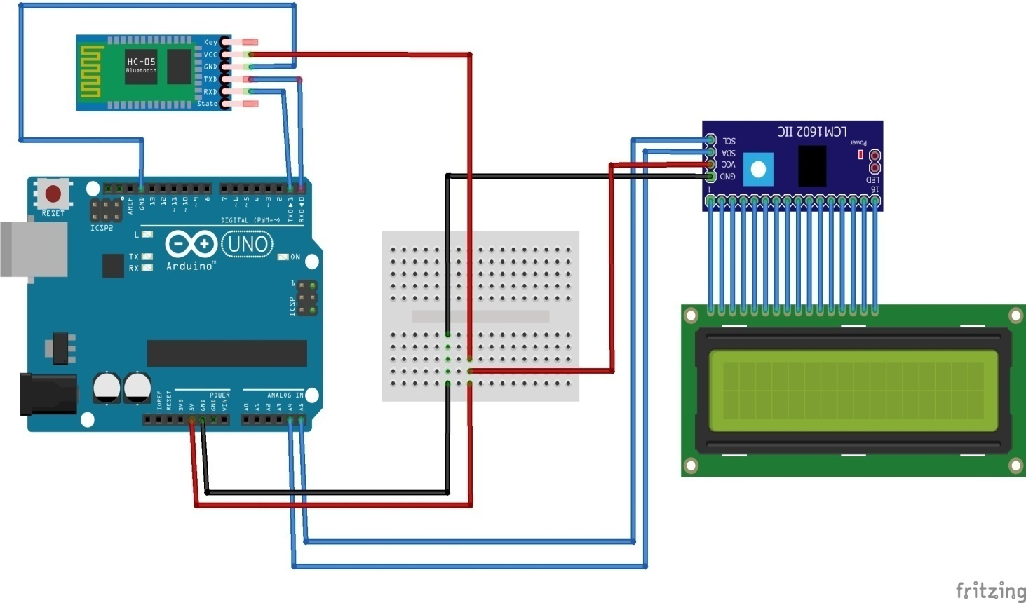

Above circuit diagram speaks it all for the sake of this project.

TheLCD’s registers from D0 to D7 and Vcc, GND, RS, R/W pins will be connected toI2C.

GND pin of I2C is connected Ground pin (GND) of the Arduino..

VCC pin of I2C is connected to Arduino 5V pin. (Because we need to supply 5v to LCD)

SDA pin of I2C is connected  A4of theb Arduino.

SCL pin of I2C is connectedA5pin of the Arduino.

The Bluetooth GND pin is connected with Arduino GND pin.

The VCC pin is connected with Arduino 5V.

The TX pin of Bluetooth is connected to RX pin of Arduino.

The RX pin of Bluetooth is connected to TX pin of Arduino.

So, data sent to the bluetooth module using mobile or any bluetooth enabled devices through bluetooth terminal apps are fetched to the Arduino and in return displayed on the LCD.

## Implementation of NodeMcu

In this we will learn how to interface an **LCD** (**L**iquid **C**rystal **D**isplay) to the NodeMCU board.

These **16x2** LCDs are very popular and broadly used in electronics projects as they are good for displaying information like sensor data from your project, and also they are very cheap.

**Step 1: Things Needed**

* 1. NodeMCU
  2. 16x2 LCD
  3. I2C Board
  4. Breadboard
  5. Jumper Wires
  6. Micro USB Cable

**Software Components**

1. Arduino IDE

### Step 2: Circuit Connection

Connecting LCD to I2C and then interfacing it to NodeMCU is very simple.

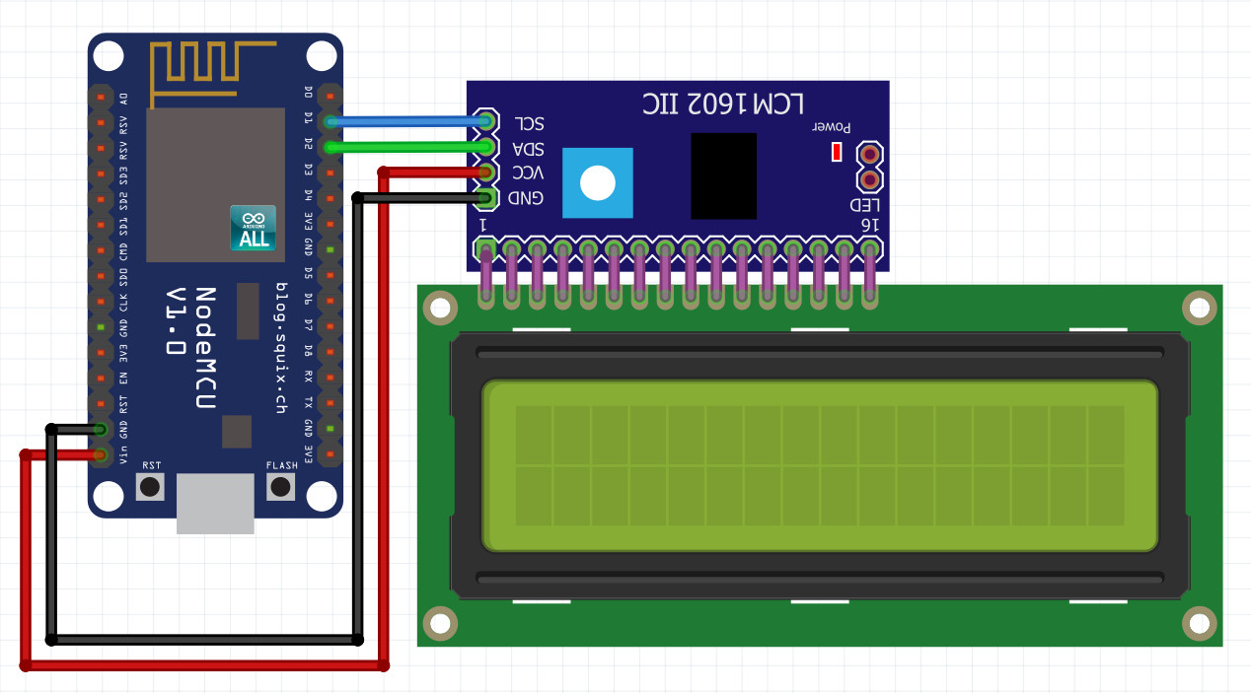The**LCD’s registers** from D0 to D7 and Vcc, GND, RS, R/W pins will be connected to**I2C**.

GND pin of I2C is connected Ground pin (GND) of the NodeMCU.

VCC pin of I2C is connected Vin pin of the NodeMCU. (Because we need to supply 5v to LCD)

SDA pin of I2C is connected D2of the NodeMCU.

SCL pin of I2C is connectedD1pin of the NodeMCU.

## Working

### Working of RF Module: Annotation 2019-08-25 173408

figure.

Open Arduino software upload the code and click the tools option then select the port

. 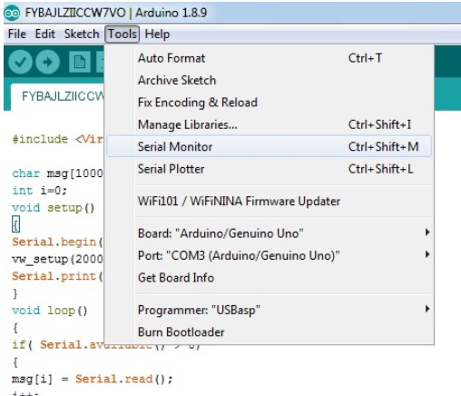

figure.

Click on the tools button then select the serial Monitor.

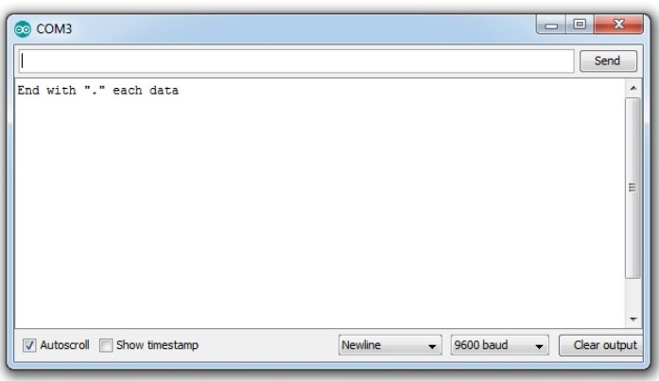

Figure .

After select the serial monitor the com3.

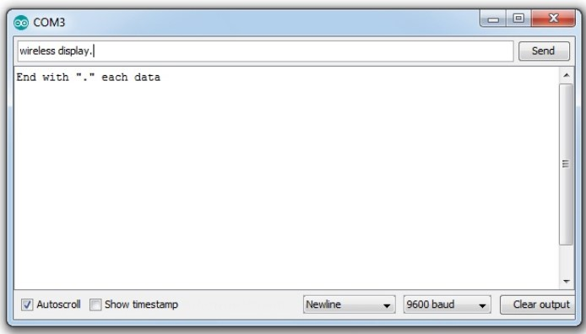

Figure .

write the message then send .

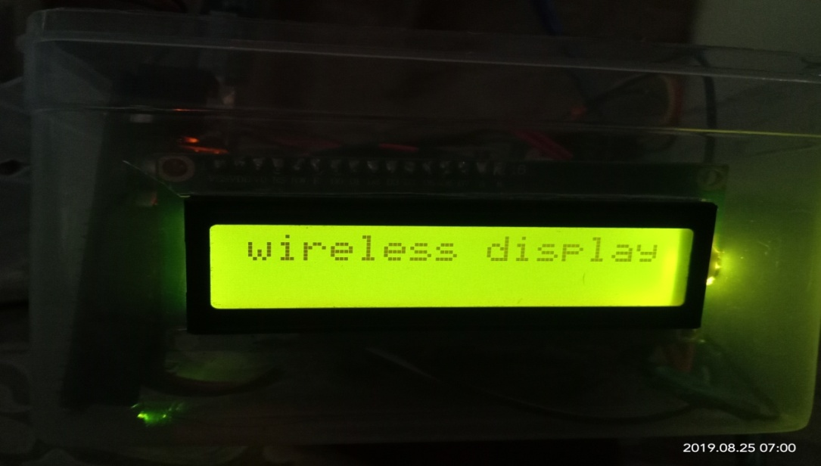

Figure .

after sending the message,the message display on the screen.

### Workig of Buetooth:

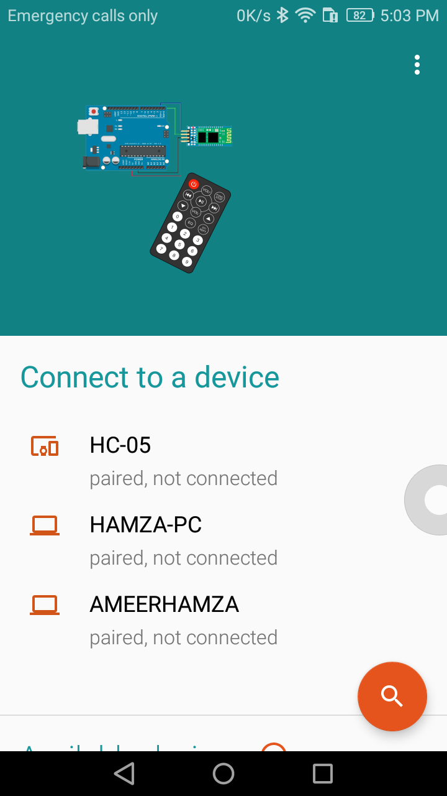

Figure .

First of all open the arduino Bluetooth software then searching the blutooth device HC-05.

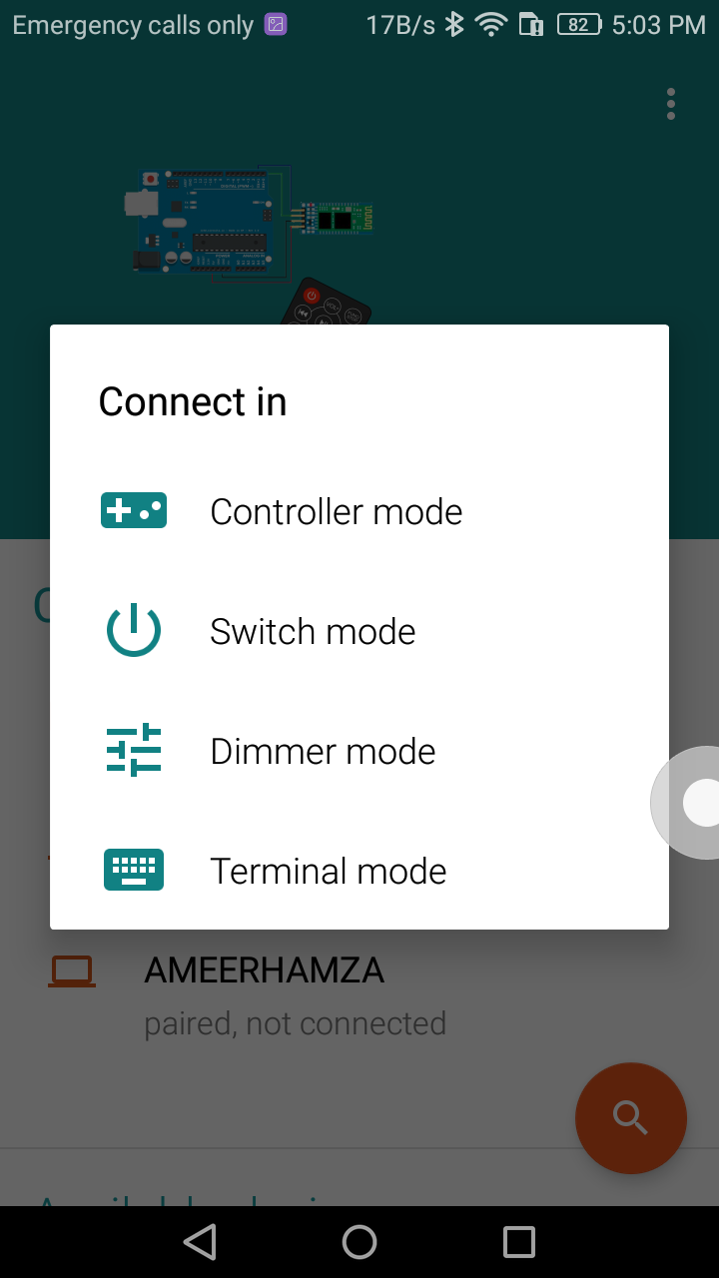

Figure .

After connecting the HC-05,select the terminal mode.

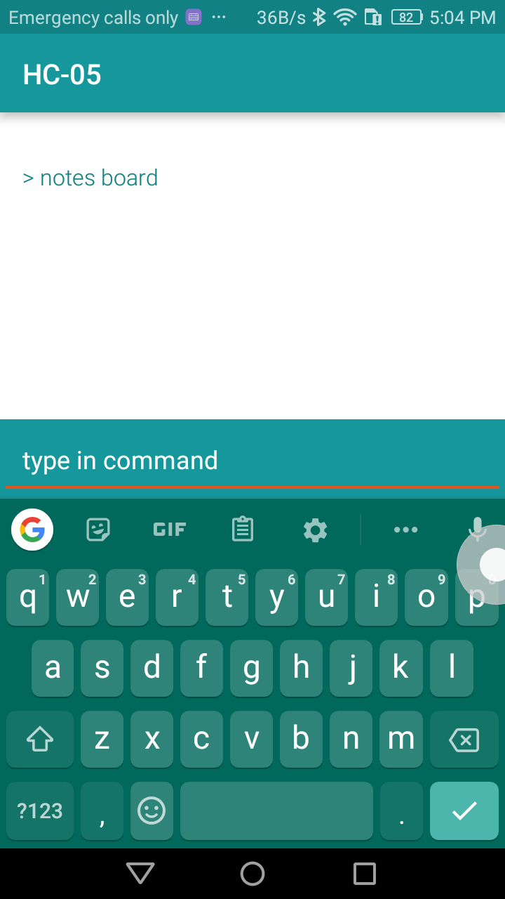

Figure .

After open the terminal mode,type the message and click on send button.

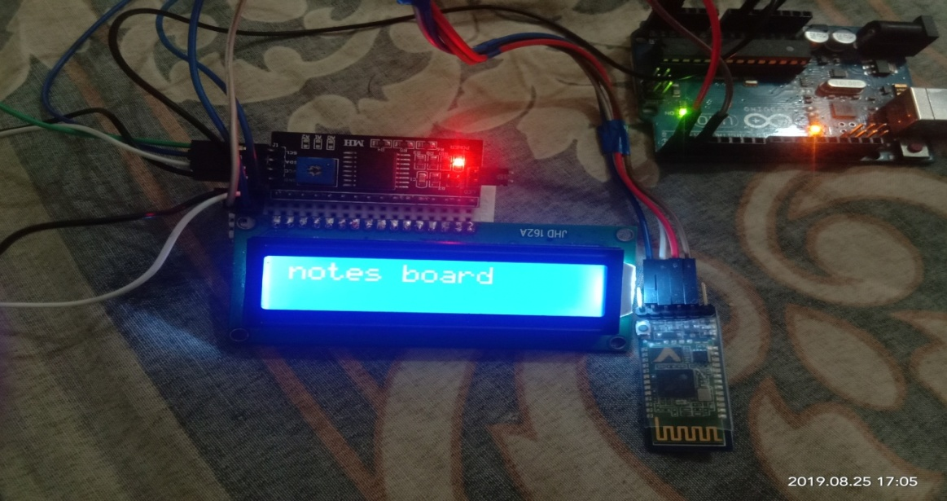

Figure .

Message is received and display on the LCD.

### Working of NodeMcu:

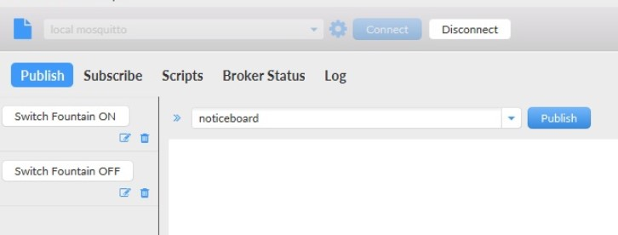

Figure .

Firstly open the MQTT.fx server

.

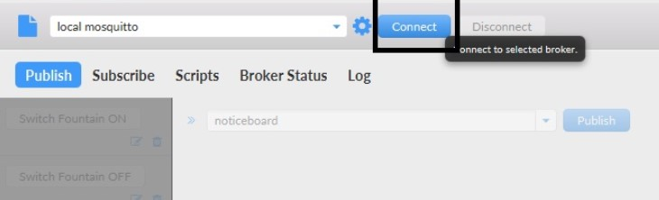

Figure .

After open the MQTT server.Click on the connect button and wait for connect.

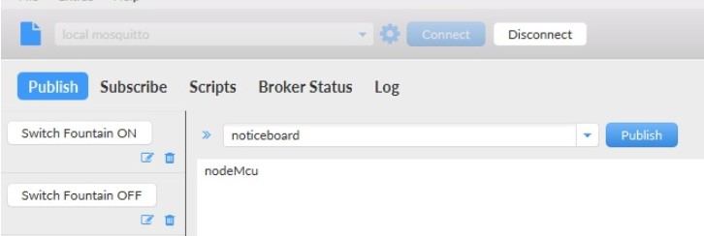

Figure .

When server is connected with Internet , Then type the message and click on the publish button.

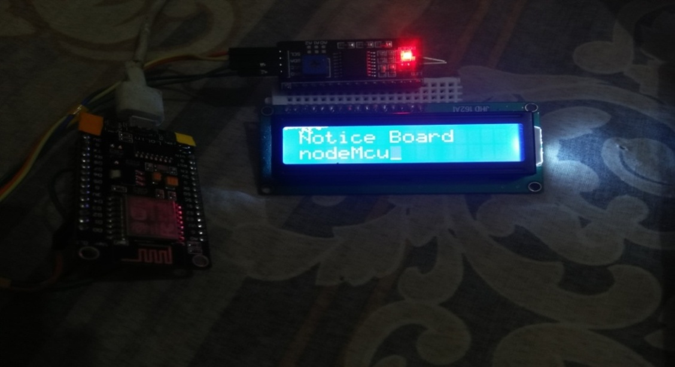

Figure .

After sending the message through MQTT server , message show on the LCD.

## Code of Desktop Application

### Code of RF Transmitter

1.#include <VirtualWire.h>

1. char msg[1000];
2. int i=0;
3. void setup()
4. {
5. Serial.begin(9600);
6. vw_setup(2000);
7. Serial.print("End with \".\" each data");
8. }
9. void loop()
10. {
11. if( Serial.available() > 0)
12. {
13. msg[i] = Serial.read();
14. i++;
15. }
16. if( msg[i-1] == '.')
17. {
18. msg[i-1] = '\0';
19. i=0;
20. vw_send((byte *)msg, strlen(msg));
21. delay(100);
22. }
23. }

### Code of RF Receiver

1. #include <VirtualWire.h>
2. #include <LiquidCrystal.h>
3. LiquidCrystal lcd(7, 6, 5, 4, 3, 2);
4. char cad[100];
5. int pos = 0;
6. void setup()
7. {
8. lcd.begin(16, 2);
9. lcd.setCursor(1, 0);
10. vw_setup(2000);
11. vw_rx_start();
12. }
13. void loop()
14. {
15. byte buf[VW_MAX_MESSAGE_LEN];
16. byte buflen = VW_MAX_MESSAGE_LEN;
17. int i;
18. if( vw_get_message(buf, &buflen) )
19. {
20. if(pos < 2)
21. lcd.setCursor(0, pos);
22. else
23. {
24. pos=0;
25. lcd.clear();
26. }
27. for (i = 1; i < buflen; i++)
28. {
29. lcd.print((char)buf[i]);
30. pos++;
31. }
32. }
33. }

### Code of Bluetooth:

1. #include <Wire.h>
2. #include <LiquidCrystal_I2C.h>
3. LiquidCrystal_I2C lcd(0x3F,20,4); // set the LCD address to 0x27 for a 16 chars and 2 line display
4. void setup()
5. {
6. lcd.init(); // initialize the lcd
7. lcd.backlight();
8. Serial.begin(9600);
9. }
10. void loop()
11. {
12. // when characters arrive over the serial port...
13. if (Serial.available()) {
14. // wait a bit for the entire message to arrive
15. delay(100);
16. // clear the screen
17. lcd.clear();
18. // read all the available characters
19. while (Serial.available() > 0) {
20. // display each character to the LCD
21. lcd.write(Serial.read());
22. }
23. }
24. }

### Code of NodeMcu:

1. #include <ESP8266WiFi.h>
2. #include <PubSubClient.h>
3. #include <Wire.h> // This library is already built in to the Arduino IDE
4. #include <LiquidCrystal_I2C.h> //This library you can add via Include Library > Manage Library >
5. LiquidCrystal_I2C lcd(0x27, 20, 4);
6. // Update these with values suitable for your network.
7. const char* ssid = "zayan";//put your own wifi ssid here
8. const char* password = "Ameeni727";// put your wifi password here
9. const char* mqtt_server = "broker.mqttdashboard.com";// choose your mqtt server
10. //const char* mqtt_server = "iot.eclipse.org";
11. WiFiClient espClient;
12. PubSubClient client(espClient);
13. long lastMsg = 0;
14. char msg[50];
15. int value = 0;
16. void setup_wifi() {
17. delay(100);
18. // We start by connecting to a WiFi network
19. Serial.print("Connecting to ");
20. Serial.println(ssid);
21. WiFi.begin(ssid, password);
22. while (WiFi.status() != WL_CONNECTED)
23. {
24. delay(500);
25. Serial.print(".");
26. }
27. randomSeed(micros());
28. Serial.println("");
29. Serial.println("WiFi connected");
30. Serial.println("IP address: ");
31. Serial.println(WiFi.localIP());
32. }
33. void callback(char* topic, byte* payload, unsigned int length)
34. {
35. Serial.print("Command from MQTT broker is : [");
36. Serial.print(topic);
37. Serial.println();
38. Serial.print(" publish data is:");
39. lcd.clear();
40. {
41. for(int i=0;i<length;i++)
42. {
43. Serial.print((char)payload[i]);
44. lcd.setCursor(0, 0);
45. lcd.print("Notice Board"); // Start Print text to Line 1
46. lcd.setCursor(i, 1);
47. lcd.write((char)payload[i]);
48. }
49. }
50. Serial.println();
51. } //end callback
52. void reconnect() {
53. // Loop until we're reconnected
54. while (!client.connected())
55. {
56. Serial.print("Attempting MQTT connection...");
57. // Create a random client ID
58. String clientId = "ESP8266Client-";
59. clientId += String(random(0xffff), HEX);
60. // Attempt to connect
61. //if you MQTT broker has clientID,username and password
62. //please change following line to if (client.connect(clientId,userName,passWord))
63. if (client.connect(clientId.c_str()))
64. {
65. Serial.println("connected");
66. client.subscribe("noticeboard");
67. } else {
68. Serial.print("failed, rc=");
69. Serial.print(client.state());
70. Serial.println(" try again in 5 seconds");
71. // Wait 6 seconds before retrying
72. delay(6000);
73. }
74. }
75. }
76. void setup() {
77. Serial.begin(115200);
78. setup_wifi();
79. client.setServer(mqtt_server, 1883);
80. lcd.init(); // initializing the LCD
81. lcd.backlight(); // Enable or Turn On the backlight
82. }
83. void loop() {
84. if (!client.connected()) {
85. reconnect();
86. }
87. client.setCallback(callback);
88. client.loop();
89. }

# System Testing

For almost every system the last stage before its completion, is to integrate all the modules end to end. Usually this stage is the most difficult one, as many errors appear during the integration. Testing the system and debugging it usually takes more time than its fabrication. This chapter explains the integration, testing, debugging and the results of the overall system.

## Final Testing

Once the individual modules were completed, the whole control system was stress tested. From app command was tried to be achieved .it was seen with the help of console window of server and serial monitor of Atmel MC that data received via the server is sometimes garbage or incomplete for the WSN to operate .Due to which crashes were seen . Sometimes it takes too long for the connection to be wirelessly built. All such kind of issues were seen while finalizing Project. Efforts were put to minimize them

## Final Product

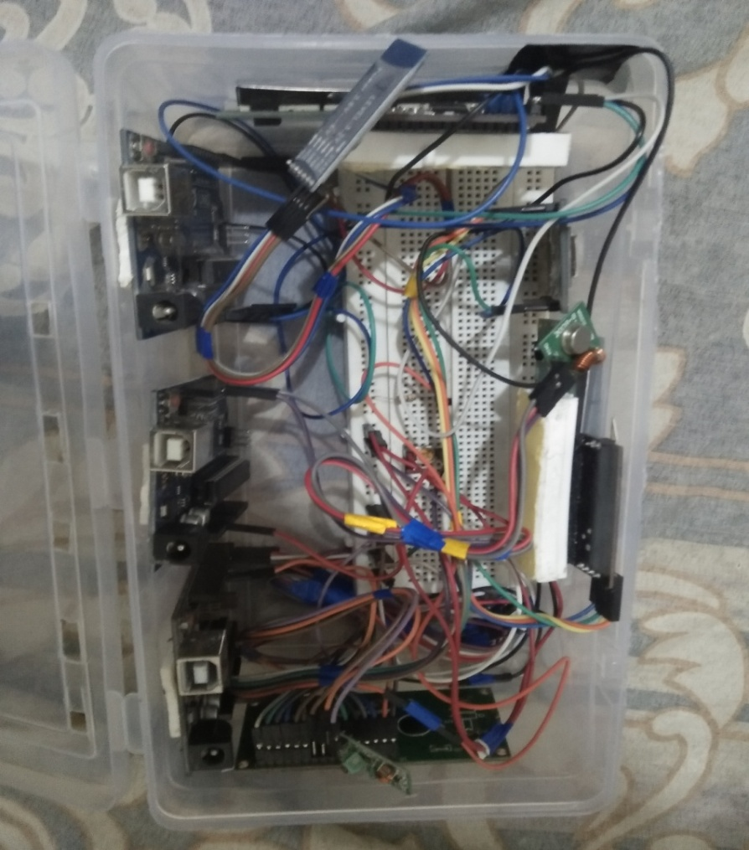

Figure .

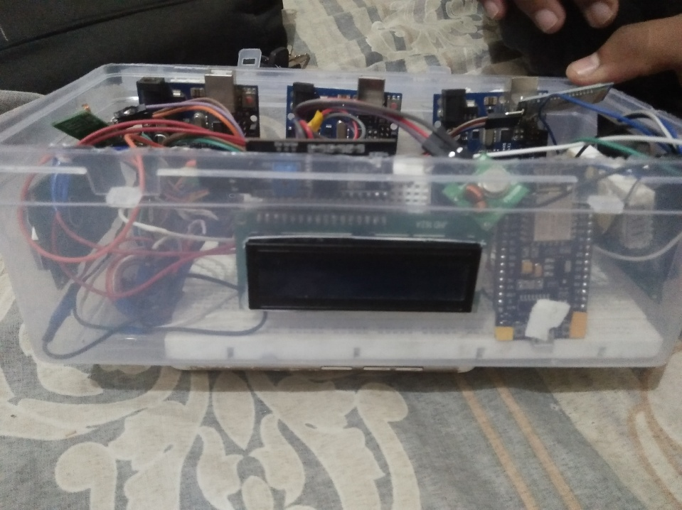

Figure .

## Future Suggestions

Electronic Notice Board is one of the application where WIFI and can be used effectively. It can also be used in Malls and Highways for Advertisement purpose. A moving display with variable speed can also be used in place of static display. Public utility places

Text can be entered from remote place- The use of GSM technology enables the user to send message from any part of the world, which would be received by modem and eventually be displayed on LCD 2)

Reduces human effort- Since it is an automated system minimum human intervention is required after programming the circuit. 3)

Saves Paper- Being completely electronic, the notice board does not use any kind of paper. Thus reducing utilization of paper. 4)

No need of complex circuit- All the connections and interfacing can be done easily and does not require any complex apparatus. 5)

User-friendly- Since the system is easy to operate it does not require any special expertise or skills.

## Conclusion

With the day to day advancement in technology the Notice Boards are also evolving from a hand- written system to a digital display and further to a Wireless Display System. The paper reflects a wireless Notice Board System with a NodeMcu module , which displays the desired notices in the form of a text on the LCD screen through a SMS. Multiple notices can be displayed simultaneously in parallel with message. Use of a password scheme before the message and for starting the notice board display has also enhanced the security concerns.

The prototype of the proposed NodeMcu based electronic notice board is successfully designed. It can be easily integrated with all general purpose display board thus proving its mobility. The system accepts the message to be displayed in the form of Short Message Service (SMS), stores it, checks for its validation and then displays it on the display unit if it from an authorized user. This system supports only one message at a time. This limitation can be tackled by use of higher end microcontroller and extended RAM. The proposed system can be efficiently used for transfer of message instantly in the campus.

## Refrence:

[https://www.arduino.cc](https://www.arduino.cc/)

<https://www.google.com>

<https://www.instructables.com>

<https://howtomechatronics.com/tutorials>

<https://www.esp8266.com>

<https://fritzing.org/home/>

<https://en.wikipedia.org/>